Miller/Gougler/Miller Combination Locks

These are interesting combination locks because they do not use multiple wheels. Instead they rely on an intricate cam and stylus. As a result, they do not have a numbered combination in the ordinary sense, instead you count clicks; some have numbers marked but others have no markings at all. Sometimes they are called labyrinth locks.

These padlocks are attractive to lock collectors with a small budget because most are not very expensive, yet there is a reasonable variety if you take into account the 3 major eras and other factors. Door locks seem to be extremely rare, as well as automobile gas caps, and some of the early steel-cased padlocks.

Although these were available to individual consumers, it appears a major market segment was school lockers. Most advertisements discovered so far are in education journals, and many padlocks have both a factory blind code and another code stamped on them; it is presumed the second code was requested by the customer and provides a second blind code which the customer was given, so that the factory code would not become widely known even if the customer’s code list was copied. Other customers included corporations such as B.F. Goodrich and Westinghouse.

Company Names and a very brief history

The J. B. Miller Keyless Lock Company of Kent, Ohio, started in 1888. This name is often abbreviated “J.B.M.K.L.” on early padlocks though some of the very earliest omit the J.B.

(Not to be confused with the Miller Lock Company of Frankford/Philadelphia PA, which also marketed a keyless combination lock ca. 1889-1908 or longer; by 1910 ads in Association Men show a very similar lock being sold by Corbin Cabinet Lock suggesting that CCL purchased that Miller Lock Company; “Awarded the silver medal at Paris, 1889”).

Gougler Keyless Locks: also of Kent, Ohio. They took over in 1944 or 1945. By 1965 the name used in advertising was C. L. Gougler Machine Company, Lock Division.

Miller: In the 1970s, the Gougler lock division was sold to a Miller family unrelated to the original Millers, who formed the Miller Company (or Miller Industries) of Columbus (not Kent), Ohio. They went out of business by November 27, 1978 (that was the date when the assets were appraised prior to a liquidation auction).

Red Dot: Most padlocks (except for very early ones) have a red dot in the center of the dial, though it might be worn off. The dot and the phrase were trademarked in 1946 by Gougler; the applications state they were in use as early as 1929.

Detailed History:

1875/1876 -- As a prelude, the Railway Speed Recorder Company was organized. The recorder was perfected by James B. Miller (Portage Heritage, 1957, page 329). Although “History of Portage County, Ohio” (http://books.google.com/books?id=RVDWAAAAMAAJ&pg=PA449&lpg=PA449&dq=%22railway+speed+recorder+company%22&source=bl&ots=SVJLTIwB1g&sig=qZLtGxtFD4g67PbkYJjYLPEF_m0&hl=en&ei=CDdZS7qyL5WsNsDQ0IwP&sa=X&oi=book_result&ct=result&resnum=8&ved=0CBkQ6AEwBw#v=onepage&q=%22railway%20speed%20recorder%20company%22&f=false) states the company was organized November 2, 1875, with J. B. Miller being one of the members. A possibly-relevant US patent is 247,459 (1880/1881) which is a speed recorder invented by William W. Wythe who was also a member of the company. See also US patents 173,251, 198,323 and 203,865. Though invented by Wythe, J. B. Miller apparently perfected the device. When railroad block signaling was developed, the recorder was made obsolete and Miller moved on to the lock industry [Portage Pathways].

For an unknown time, James lived in Brimfield (“for over a decade”), and was married to Carolyn “Carrie” Snyder (Brimfield). However, “History of Portage County, Ohio” (http://books.google.com/books?id=RVDWAAAAMAAJ&pg=PA449&lpg=PA449&dq=%22railway+speed+recorder+company%22&source=bl&ots=SVJLTIwB1g&sig=qZLtGxtFD4g67PbkYJjYLPEF_m0&hl=en&ei=CDdZS7qyL5WsNsDQ0IwP&sa=X&oi=book_result&ct=result&resnum=8&ved=0CBkQ6AEwBw#v=onepage&q=%22railway%20speed%20recorder%20company%22&f=false) claims that J. B. Miller was married to Effie S. Parsons, the adopted daughter of Edward A. Parsons, secretary and treasurer of the Railway Speed Recorder Company. Because dates are unknown, it is possible that Miller married twice (or more), for unknown reasons.

1888 -- The J B Miller Keyless Lock Company of Kent, Ohio, started in 1888 [Portage Heritage, 1957, page 213]. This name is often abbreviated “J.B.M.K.L.”. At first, they made and marketed “Doud’s Patent Permutation Lock” [Portage Pathways]. The plant was on Lock Street, off Lake Street.

1889 -- Lure of the Lock, page 128, shows a drawer lock estimated to be from 1889, along with two spare cam wheels to allow changing the combination. It seems to include design features of Douds’ patents 431,450 and 431,451 (both filed in 1889).

1891 – A school in Melrose Park, Illinois, begins using Miller Keyless padlocks; 50 years later this is mentioned in The American School Board Journal, v. 102 page 95, 1941. The 1941 address is listed as 200 Lock Street in Kent, and mentions the Red Dot trademark.

1892 – Yale Gymnasium starts using Miller locks (Yearbook of YMCA, 1902, “ten years ago”). However, the 1905 issue says the same thing (“ten years ago”), implying 1895. They probably re-ran the same ad year after year without worrying about people like me who would notice the inconsistency.

1893 – The Miller Keyless Lock Co. (Kent) is mentioned in the Annual Report of the Department of Inspection of Workshops and Factories, page 51 number 81. They needed to provide toilet facilities for women, and fill out accident reports. Complied.

1899 – The Miller Keyless Lock Co. is mentioned in the Annual Report of the Department of Inspection of Workshops and Factories (Ohio), 1899 page 31, as entry number 174 but Google Books’ snippet view won’t allow viewing the entry.

1901 – Ad for locker lock 406, set 805, set 800; and lock/latch 620; The Miller Keyless Lock Co., Kent (Jubilee Year Book, YMCA, 1901, page xxxix). It lists J. B. Miller as the manager.

1902 – “The keyless lock can be changed from a 3-number to a 5-number combination” but this may not refer to the Miller (Google Books’ snippet view is ambiguous though it does appear to be part of a JB Miller ad) (Year Book, YMCA, 1902, page 275).

1906 – Ad for No. 415, and No. 406 set 805, Miller Keyless Lock Co., Kent (Association Men, January 1906).

1908 – Ad for No. 415 and No. 4<unreadable> for metal lockers, Miller Keyless Locks, The J. B. Miller Keyless Lock Co., Kent (Association Men, December 1908, page 150 in their numbering, which is page 59 in the Google Books PDF file).

1909 – Ad for Miller Keyless, J. B. Miller Keyless Lock Co., Kent (American Physical Education Review, January 1909).

1910 – Ad for Miller Keyless Locks, No. 415 for metal lockers, The J. B. Miller Keyless Lock Co., Kent (Association Men YMCA February 1910).

1912 – Ads for Miller Keyless Locks though Google’s snippet view won’t reveal much, one reveals “Pad Lock No. 5 – Steel” and “Pad Lock No. 6 – Brass” (Association Men Volume 37, 1912, pages 265, 375, and 49).

1913 – Business in Kent was very good, and the (J. B.) Miller Keyless Lock Company, with its crew of six, had difficulty keeping up with orders [Portage Pathways, page 226, in an article about 1913 originally published May 15, 1988].

1924 – “The Miller Keyless Lock Co., Kent, Ohio, contemplates a factory addition. JB Miller is president and James P. Miller, secretary and treasurer…” (Iron Age, vol 114 1924 page 1039). I suspect James P. Miller is JB’s son, referred to as Jamie later.

1927 – James B. Miller died, the business passed to his two sons, Jamie and Ned, who “ran the company and manufactured the lock under the name of Miller Keyless Locks…” [Portage Pathways]. I believe this may be correct in that Miller Keyless Locks might have been the collective name of the products, but the company name was still J. B. Miller Keyless Lock Company.

1920s? – In Brimfield and its People: Life in a Western Reserve Township, 1816-1941 (Edgar L. McCormick, 1988, page 201) there is a snippet suggesting that Ned Miller founded the Miller Keyless Lock Company, which is clearly incorrect. He also lived in Brimfield at the time, and played trombone in a band.

1929 – Red Dot, i.e. the actual red dot, as well as the name “Red Dot” are the subject of US trademark applications 426,385 (the dot) and 424,030 (the name). Both applications are by the C. L. Gougler Keyless Lock Company, Lake Street, Kent, assigned to the C. L. Gougler Machine Company, Kent. Though the applications were in 1946, the stated date of first use is 1929, which is why this note is under 1929 as well as 1946.

1936 – Ad for “Miller Keyless Lock Company, J. B.” at 912 Locke St., Kent (School and College Management, volumes 6-7, 1936)

1936 – Machinist’s Monthly Journal (Volume 48, page 760) reports on new contract terms between machinists and the JB Miller Keyless Lock Company.

1939 – The JB Miller Keyless Lock Co., 912 Lock St (Ohio Division of Labor Statistics, issue 28, page 27).

1939 – Ads in The School Executive magazine discuss selling padlocks for 50 years (consistent with the 1888 start date) (did they really have padlocks at the start, or just door/drawer locks?); master keyed if desired (probably conventional disc-tumbler); number 35 is click or sight, 36 sight only; finish 1 is black face, finish 2 chrome plated, finish 3 natural/lacquered. 200 Lock Street, Kent.

1940/1941 – ads in School Board Journal magazine similar to The School Executive, above, though by October they changed “For 50 years…” to “For over 50 years…” (emphasis added). Good for them, somebody was watching.

1941 – A school in Melrose Park, Ill, begins using Miller Keyless padlocks in 1891; 50 years later this is mentioned in The American School Board Journal, v. 102 page 95, 1941. The address is listed as 200 Lock Street in Kent, and mentions the Red Dot trademark.

1944 – “The J. B. Miller Keyless Lock Co., started in 1888, operating until 1944, when the C. L. Gougler Co. took it over.” (Portage Heritage, 1957, page 213).

1944/1945 -- Gougler Keyless Locks, also of Kent Ohio, purchases the company. The timeframe is confirmed by US patents (patent 2,308,892 was filed in 1941 and granted in 1943, assigned to The J. B. Miller Keyless Lock Company; patent 2,441,895 was filed in 1946 and granted in 1948, assigned to the C. L. Gougler Machine Company). Portage Heritage claims 1944, while 1945 is claimed by Portage Pathways as well as Gougler’s web pages. I’ve also seen “C. L. Gougler Keyless Lock Co.” on tags. It is likely that one is the name of the company, and one is the name of the products. Portage Pathways suggests that Gougler moved production to a factory on Lake Street.

1946 – Red Dot, i.e. the actual red dot, as well as the name “Red Dot” are the subject of trademark applications 426,385 (the dot) and 424,030 (the name). Both applications are by the C. L. Gougler Keyless Lock Company, Lake Street, Kent, assigned to the C. L. Gougler Machine Company, Kent. See also 1929, which the applications state as first use.

1956/1957 – Ads in The School Executive magazine for Gougler locks. In 1957 there are ads for the new model 40 with the flat key (which looks machined, not stamped like later ones). Also the Type 31 (in March 1957 it is “Model No.” but in May 1957 it is “Type”), which looks just like the model 30 and so far I haven’t seen any other reference to 31 and what’s different/new about it.

1957 – An item in “Safety Education” vol. 37-38 page 37, appears to match the item in College and University Business, below (regarding the new model 40), though Google Books’ snippet view does not show the entire item.

1957 – The October issue of College and University Business (v. 23 No. 4 page 84) “What’s New” section, has the following item: “Combination Lock Operates by “Clicks” -- Lock Type 40, the Master Key Combination Lock, is a new model which operates merely by counting the number of “clicks.” It helps solve the problem of locker security and permits safely-controlled inspection quickly and easily. The new lock has a slot at the bottom where a new-type of master key is inserted for emergencies and inspection. One key only is needed to open all combination locks in the series, and the master key cannot be duplicated by any commercial key machine. The strong, rugged lock has a die cast case to protect all parts from water or moisture. C. L. Gougler Keyless Lock Co., Kent, Ohio.” I assume they are discussing the key-bypass model that uses the oddly-grooved flat key, and not the other style that uses a conventional disc-tumbler lock. So the Type 40 was probably introduced in 1957. Was the other key-bypass also model 40?

1960 – Ad in The Rotarian, May 1960, describing a new residential lockset (possibly the model 83 shown in a flier, below). Inserts are available to change the combination. C. L. Gougler Keyless Lock Co., 705 Lake St., Kent.

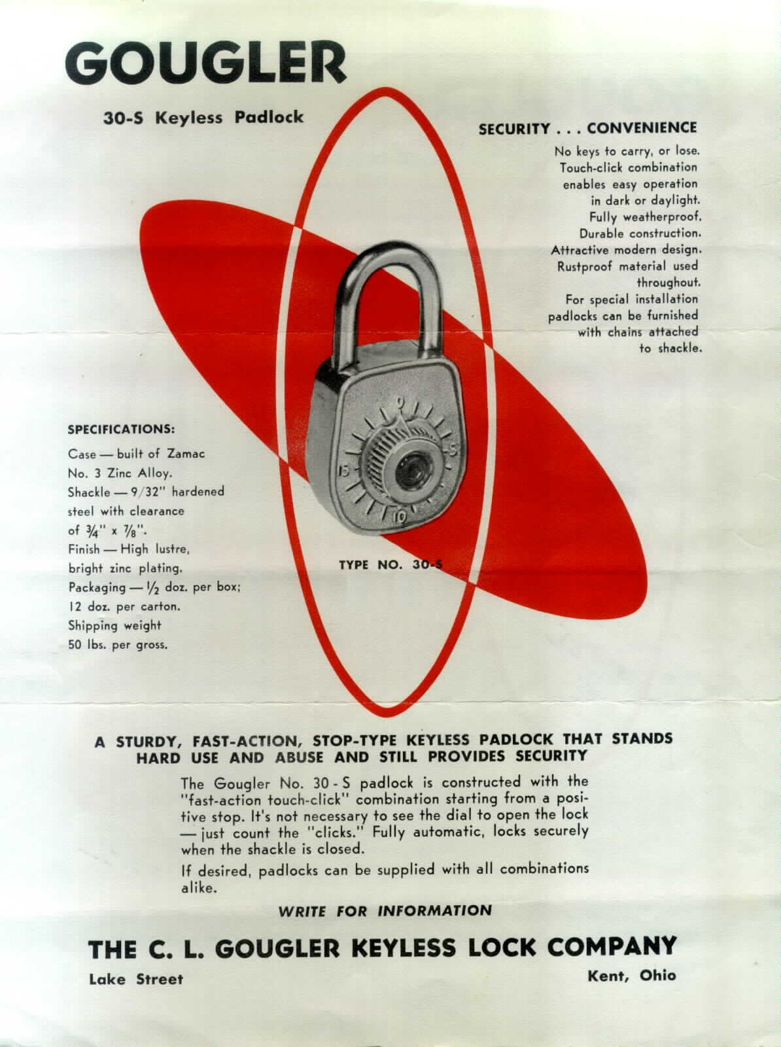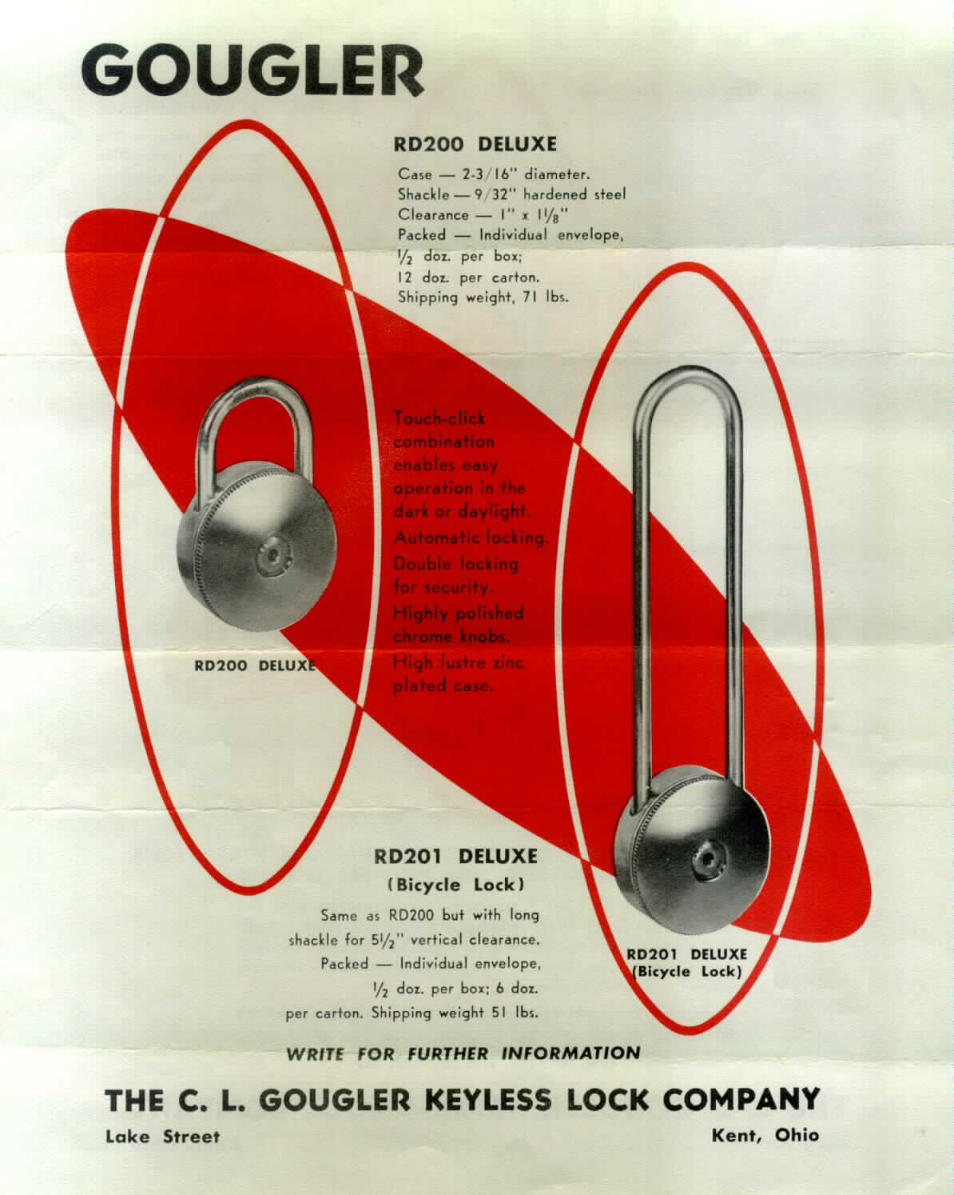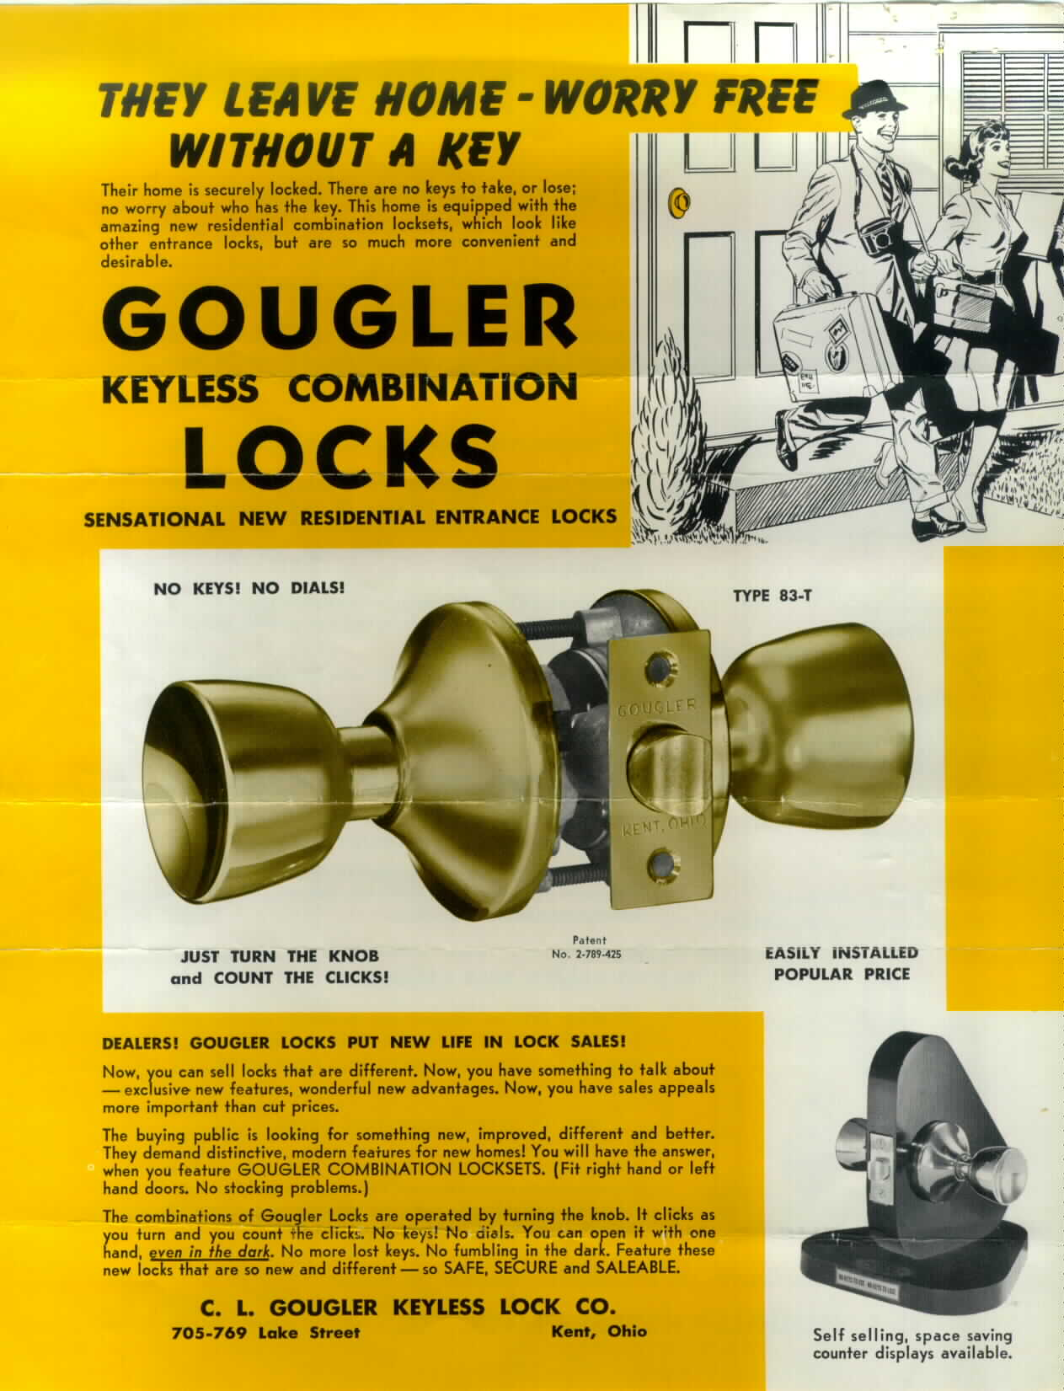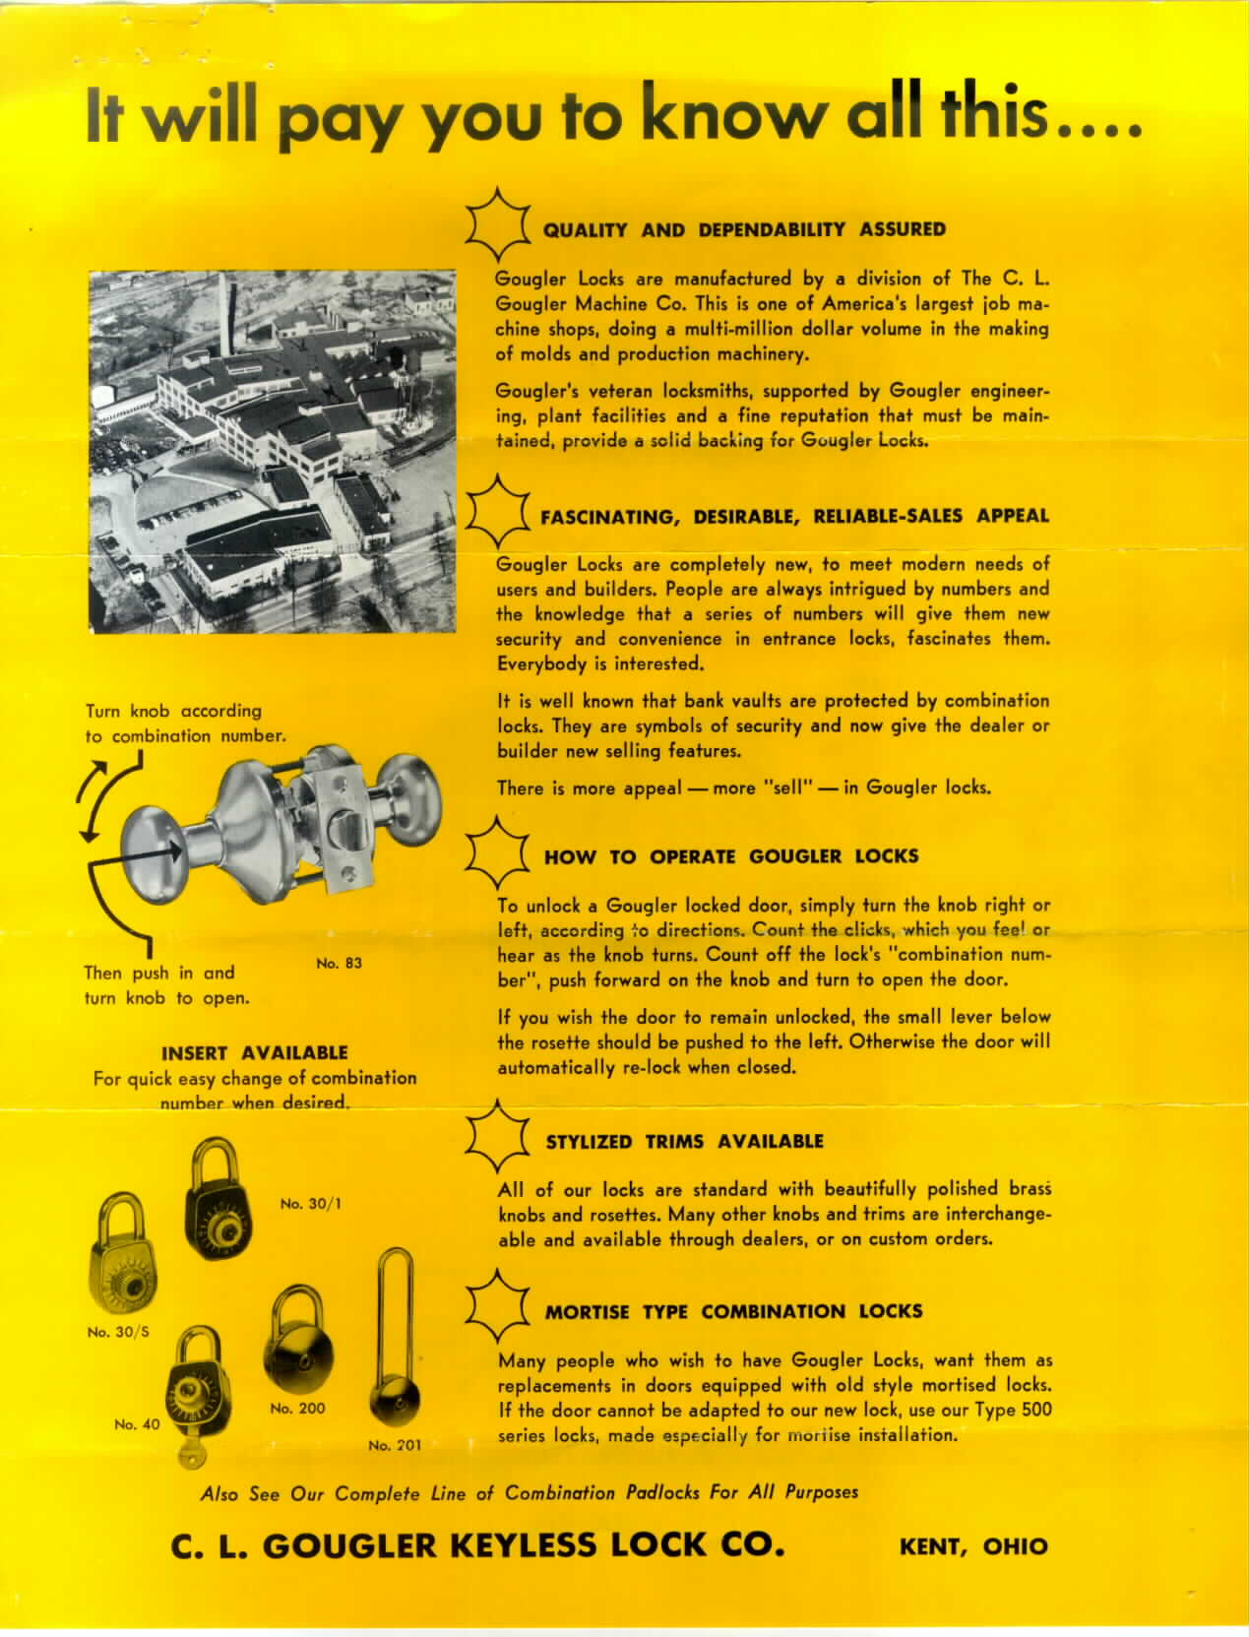

1960s? – Fliers that were on Gougler’s web site (even in 2010), possibly dating from the 1960s. They were at http://www.gougler.com/locks/locks.htm but are no longer there; use https://web.archive.org/web/20110728102227/http://www.gougler.com/locks/locks.htm instead.

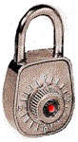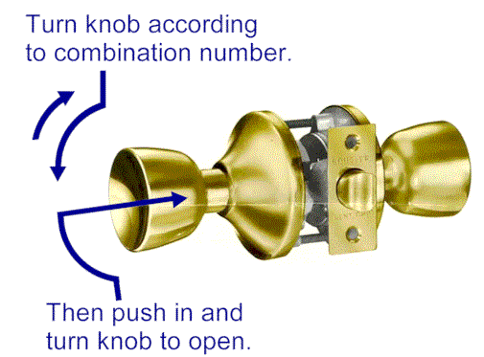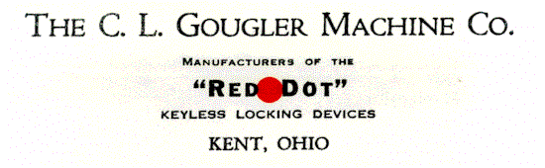

1960s? – Other images that were on Gougler’s web site along with the fliers shown above.

1964 – The daughter of the owner of The Gougler Company married, and each person at the reception received a round-face lock (probably the Model 200 or RD200) with the bride and groom’s first names and the date of the wedding (dtwiant).

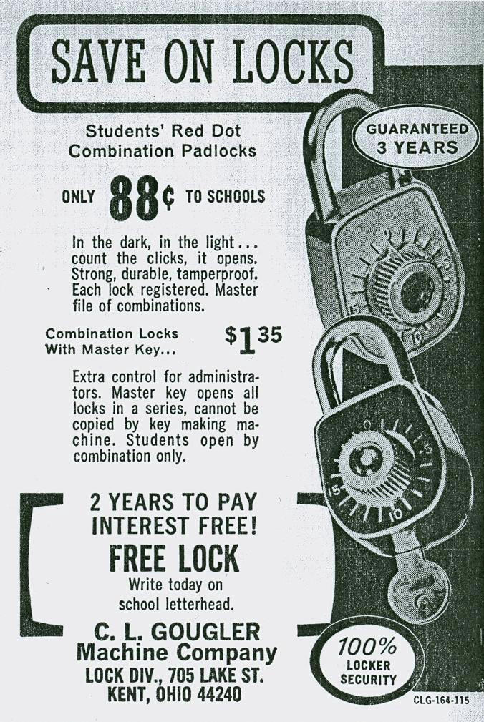
1964 – Ad in Scholastic Coach, but from now on the listed name is C. L. Gougler Machine Company, Lock Division (September 1964, page 107), $1.35 and $0.88.

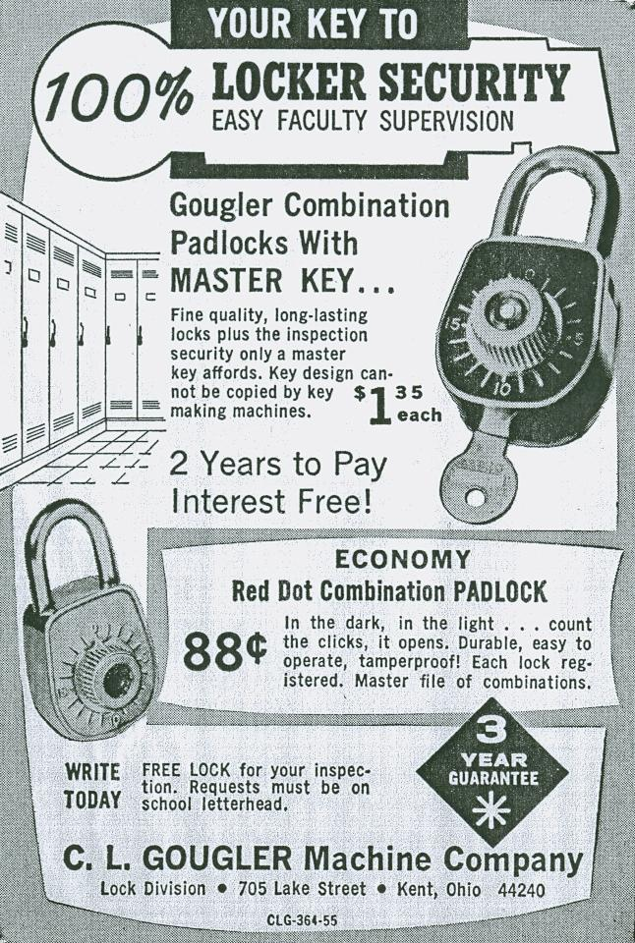
1965 – Ad in The Nation’s Schools (January 1965, page 120), $0.88 and $1.35.

1965 – Ad in Scholastic Coach (May 1965, page 87).

1964/1966 – US Patent 3,282,369 (Security Hood Latching Device for Motor Vehicles) includes a padlock, stating, “The lock 25 may be of a commercial type, such as manufactured by the C. L. Gougler Machine Company, Lock Division, Kent, Ohio, as its model No. 50.” However, no other mention of a model 50 has been found.

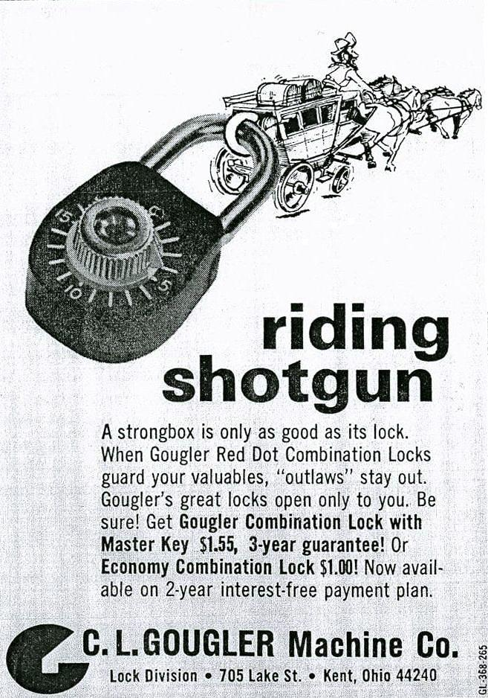
1969 – Ad in School Management, with a new Gougler logo (April 1969, page 96), $1.45 and $.95. Also August 1969 page 38, $1.55 and $1.00.

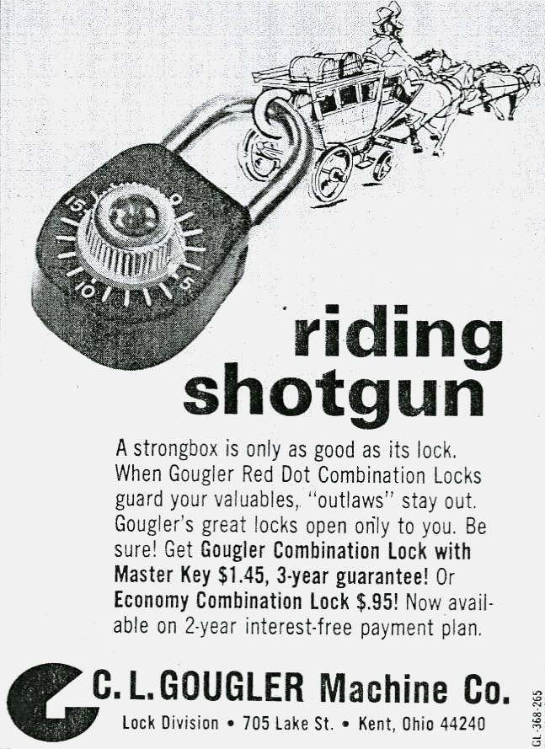
1970 – Ad in School Management, April 1970 page 37. $1.45 and $.95.

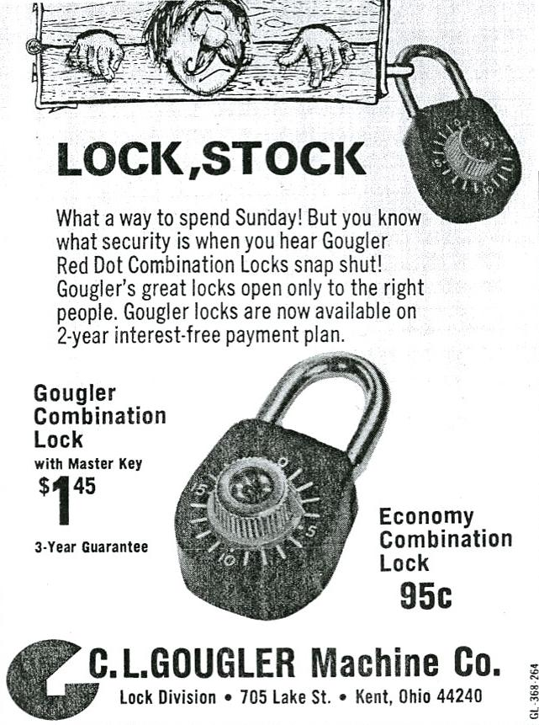
1970 – Ad in Scholastic Coach, May 1970 page 97. $1.45 and $.95.

1971 – Ad in School Management, April 1971 page 40.

1970/1972 – US Patent 3,669,211 (Remote Control Automobile Theft Prevention Mechanism) includes a padlock, and mentions Gougler: “A preferred combination lock of this type is presently available under the trademark "Gougler," manufactured by C. L. Gougler Machine Co., Kent, Ohio.”

1970s – Gougler’s lock division was sold to a family from Columbus, coincidentally named Miller. Several years later they went bankrupt [Portage Pathways]. Locks are stamped “Miller Keyless Locks.” Some lock tags say “Miller Industries Inc.” and a box included a zip code (thus 1963/1964 or later but that’s no surprise).

?? The Miller company goes out of business. The tooling is sold for scrap and destroyed, making it virtually impossible to resume manufacturing even for spare parts [Portage Pathways].

2012, the Kent factory buildings are demolished. See http://www.youtube.com/watch?v=QfwiBxcuffg and other videos by “TheRecordPub”.

Addresses

It isn’t clear which addresses are for the factory, and which are for business (if they’re different).

JB Miller: “On Lock Street off Lake Street” and 200 Lock Street, later 912 Lock Street (in some ads it is incorrectly printed 912 Locke Street).

Gougler: Lake Street, 705 Lake Street, 705-769 Lake Street, and in one case (a cardboard box) Gougler Avenue. The modern Gougler Industries is still at 705 Lake. I suspect the Gougler Avenue location was business offices only.

Miller (Columbus): 4133 Westward Avenue, Columbus, Ohio 43228 (Miller Ind., Inc.) per a tag.

Model Numbers

These are a little harder to research because few catalogs are known, and advertisements often push only one or two models. So this is hardly all-inclusive. They changed the designation from “model number” to “type” in 1957, which is ignored here. And in a 1960s flier, both are used on the same page.

5 Pad Lock, steel (1912 ad)
6 Pad Lock, brass (1912 ad)
7 unknown padlock mentioned in Reed Padlock Code Book
9 Padlock, brass, unknown date
10 unknown padlock mentioned in Reed Padlock Code Book
30-S Padlock, silver finish (1960s flier), also written 30/S
30/1 Padlock, black finish (1960s flier)
31 Padlock (1957 ad)
35 Pad Lock, click or sight (1939 ad)
36 Pad Lock, sight only (1939 ad)
40 Padlock (1956/1957 ads, brass machined flat key)
45 unknown padlock mentioned in Reed Padlock Code Book
50 Padlock, mentioned in US patent 3,282,369
83, 83-T Residential entrance lock (1960s flier)
A-100, B-100 Gas cap lock
200 Padlock, click-only (1960s flier), also RD200 Deluxe
201 Padlock, click-only, bicycle (long shackle) (1960s flier), also RD201 Deluxe
406 Locker lock, set 800 and 805 (1901 ad, 1906 ad)
415 Lock for metal lockers, set 805 (1906 ad, 1908 ad)
500 Series mortise locks (1960s flier)
525 a specific model of the 500 series mentioned in an eBay auction
545 a specific model of the 500 series mentioned in an eBay auction
620 Lock/latch (1901 ad)

Patents

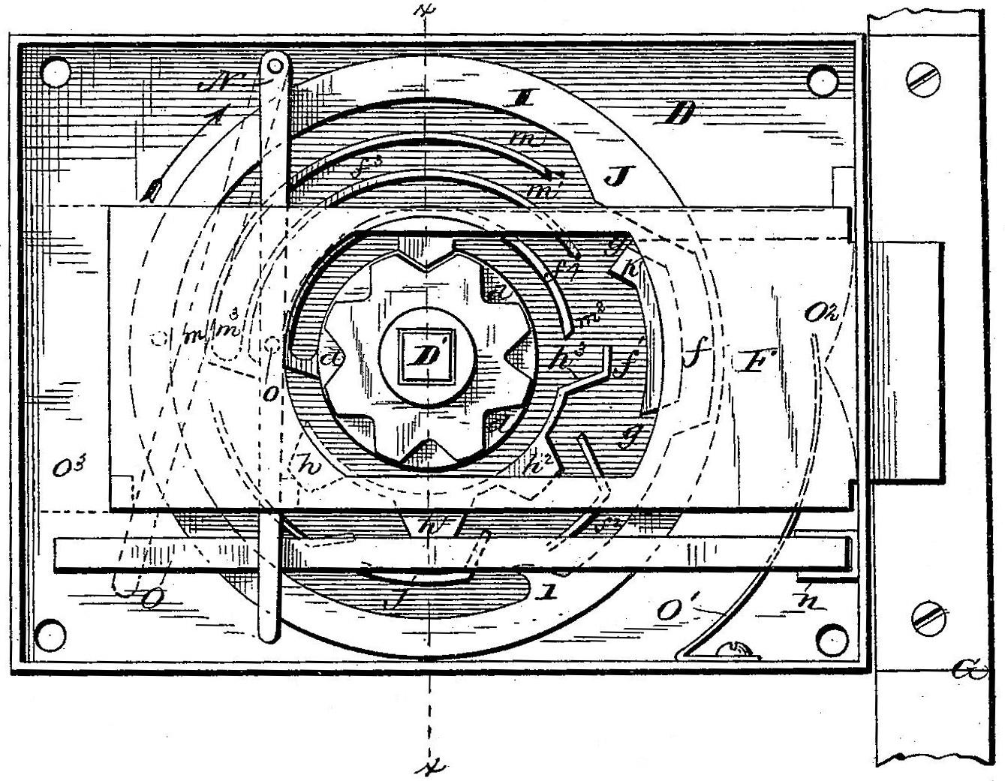
396,273 Permutation lock; 1/28/1888; 1/15/1989; Byron J. Douds, of Canton, Ohio.

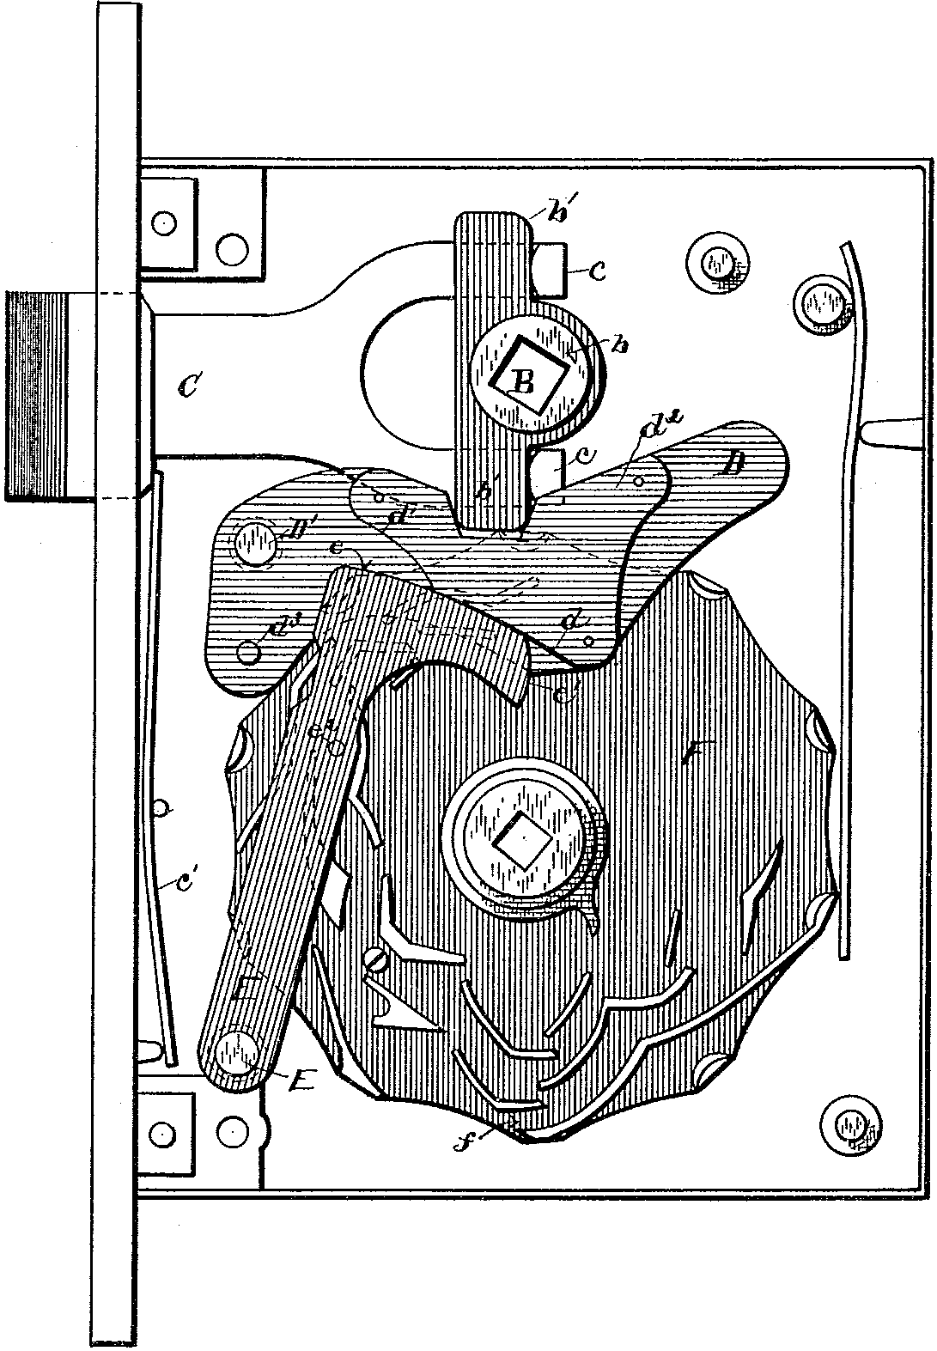
431,450 Permutation lock; 11/18/1889; 7/1/1890; Byron J. Douds, of Kent, Ohio. Described as an improvement of patent 396,273.

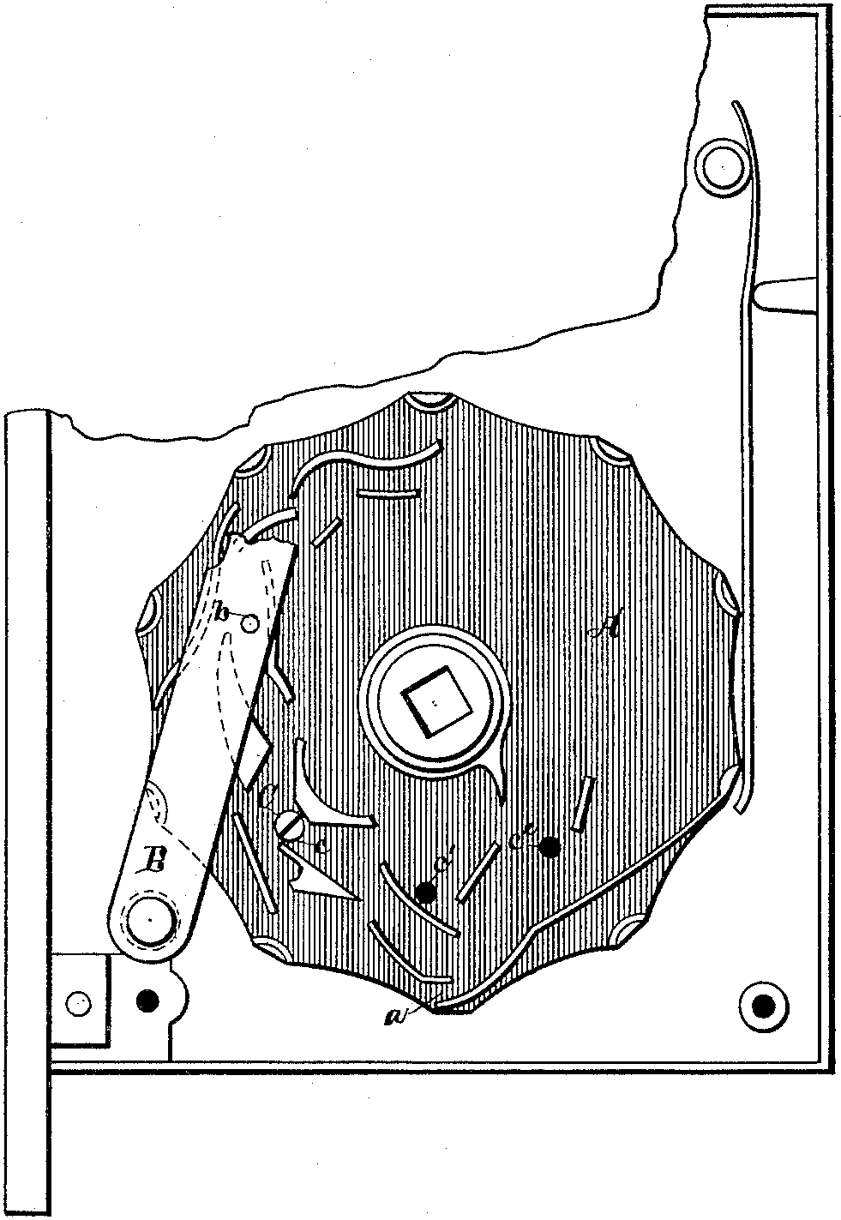
431,451 Permutation lock; 11/18/1889; 7/1/1890; Byron J. Douds, of Kent, Ohio. Described as an improvement of patent 396,273.

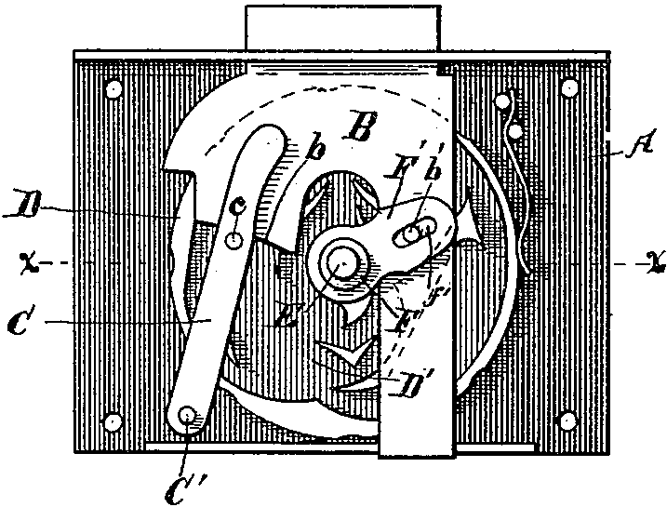
446,071 Permutation lock; 5/29/1890; 2/10/1891; James B. Miller, of Kent, Ohio. Described as an improvement of Douds’ patent 396,273.

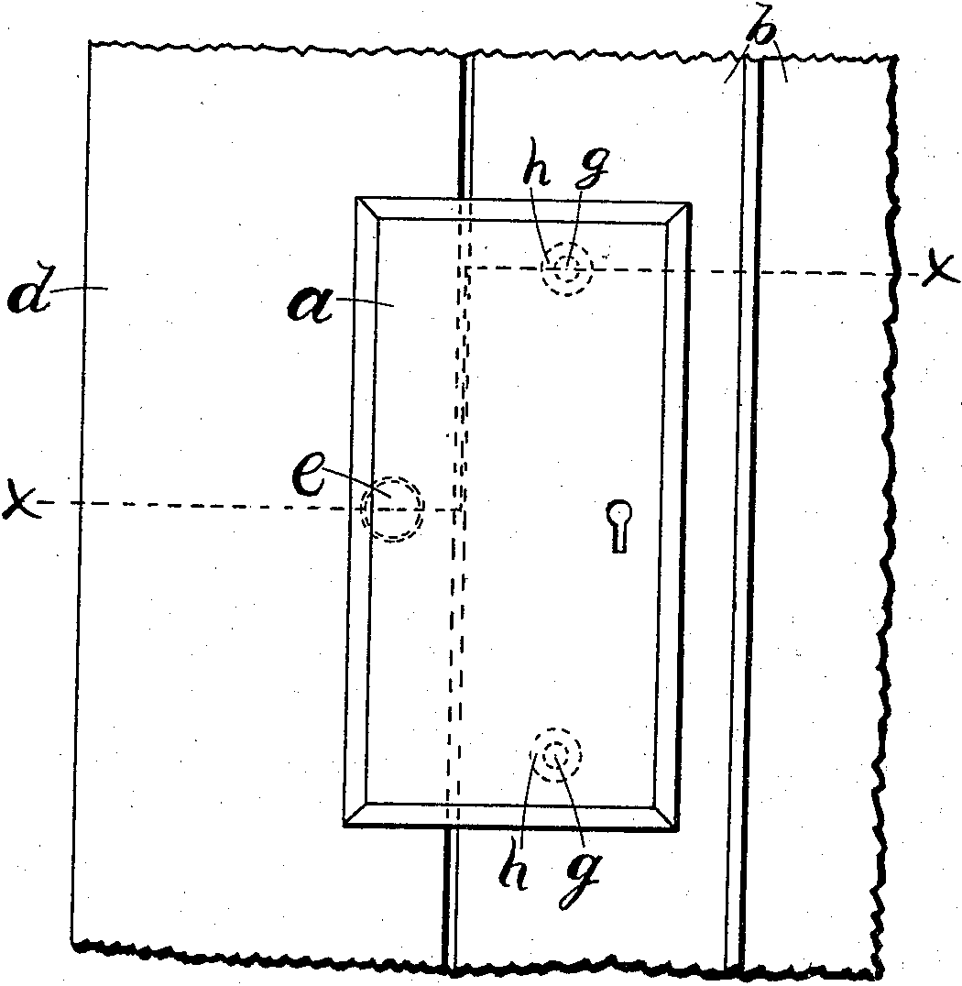
695,472 Escutcheon-Plate; 7/22/1901; 3/18/1902; James B. Miller, of Kent, Ohio. Though not a lock, the patent date is listed on the knob of an early padlock (below).
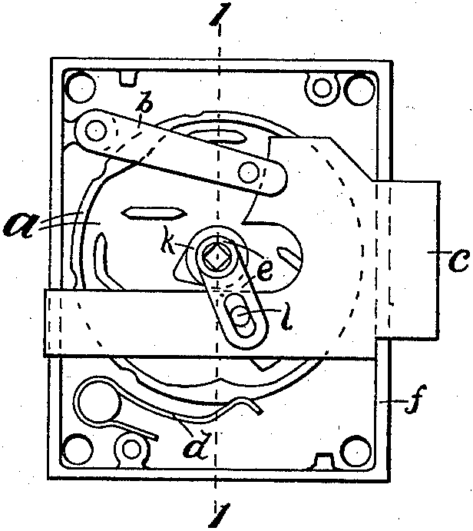
717,889 Combination Lock; 11/19/1901; 1/6/1903; James B. Miller, of Kent, Ohio.

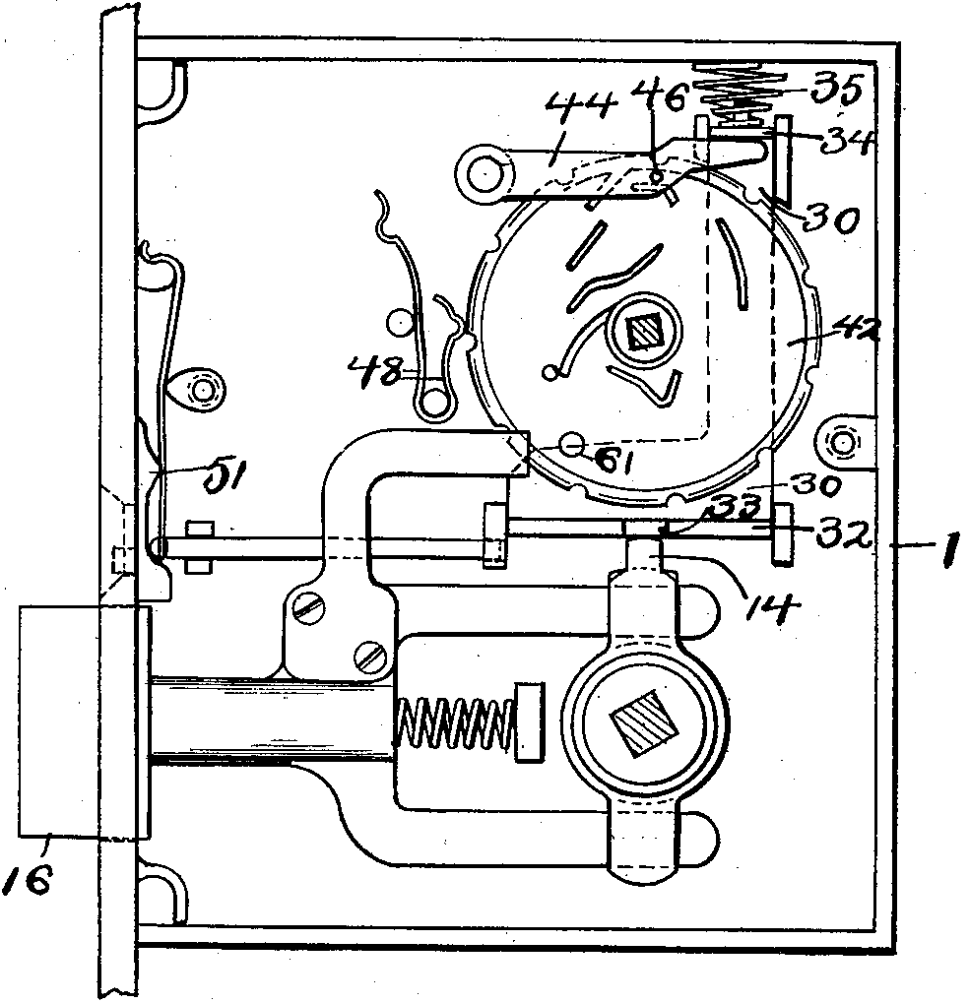
755,907 Lock; 12/4/1903; 3/29/1904; James B. Miller, of Kent, Ohio.

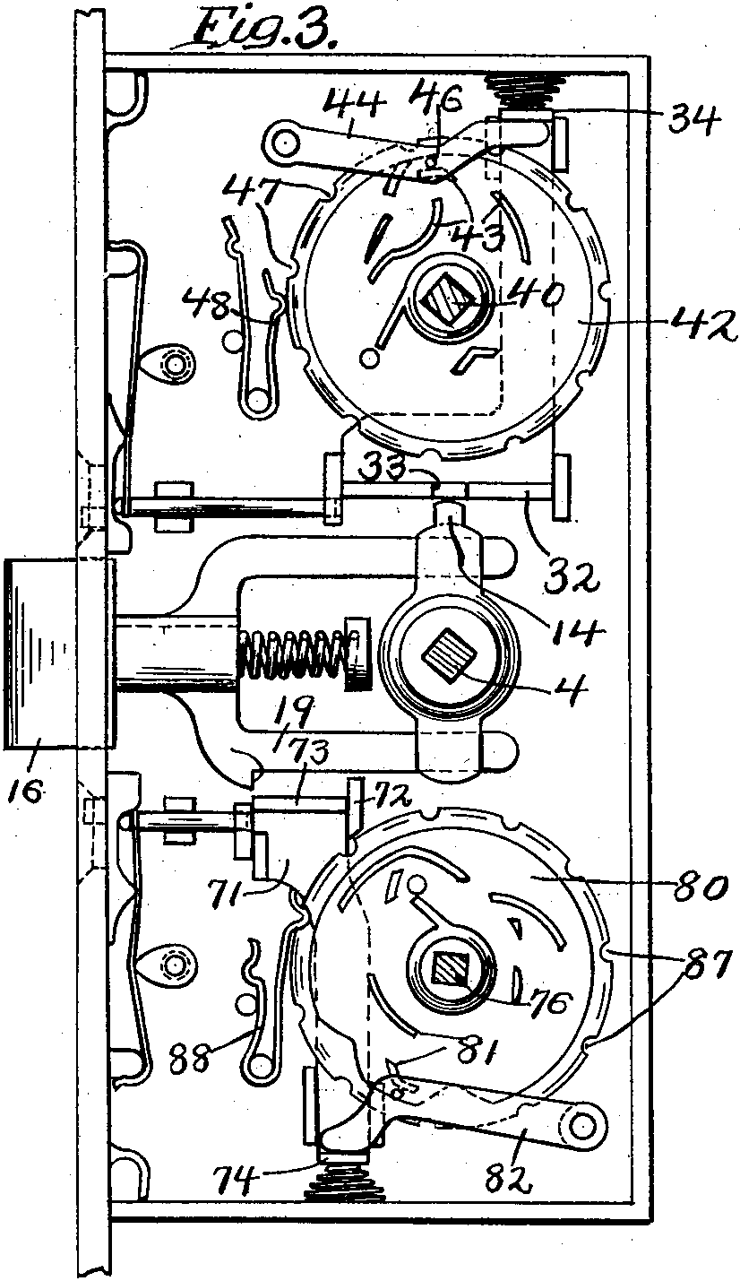
755,908 Lock; 12/4/1903; 3/29/1904; James B. Miller, of Kent, Ohio. An odd lock, it takes two combinations to enter, and one to exit.

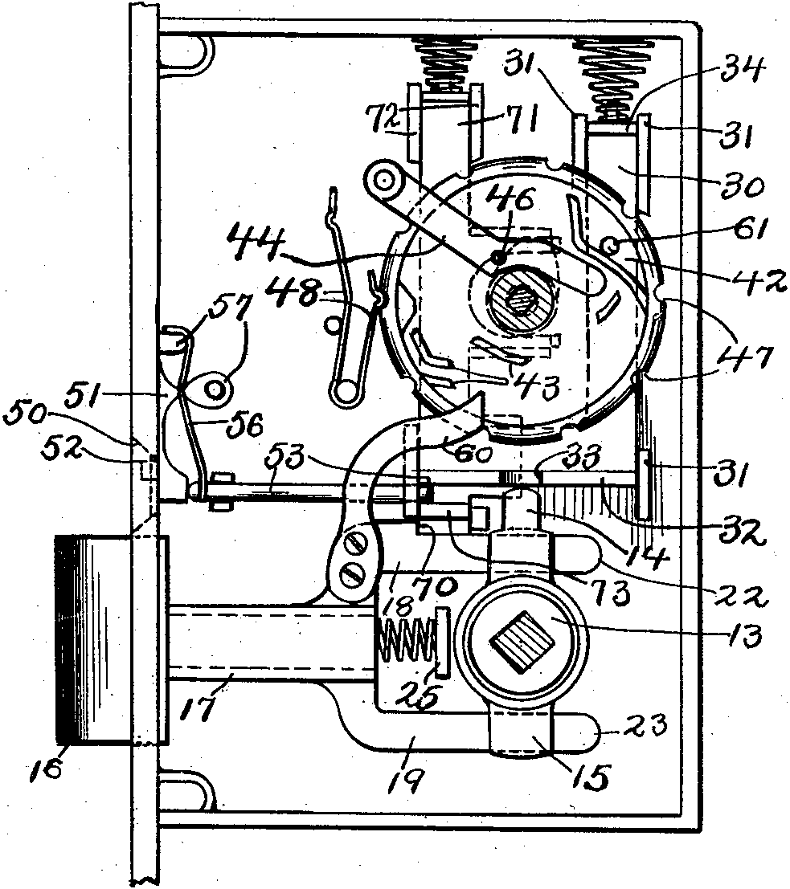
755,909 Lock; 12/4/1903; 3/29/1904; James B. Miller, of Kent, Ohio.

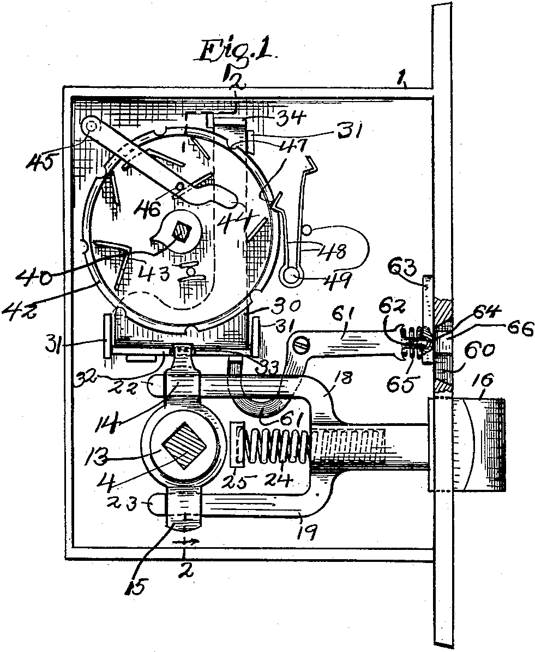
863,867 Lock; 12/3/1904; 8/20/1907; James B. Miller, of Kent, Ohio.

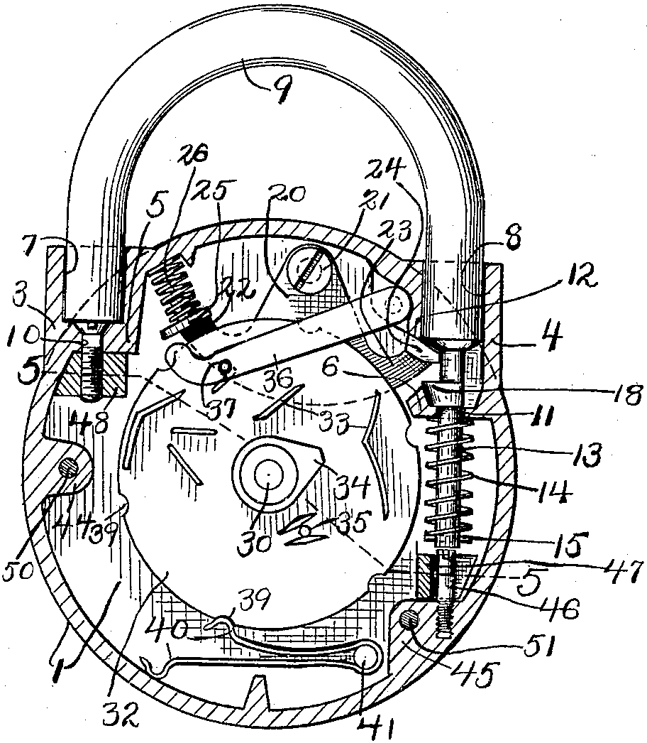
863,868 Padlock; 12/7/1904; 8/20/1907; James B. Miller, of Kent, Ohio.

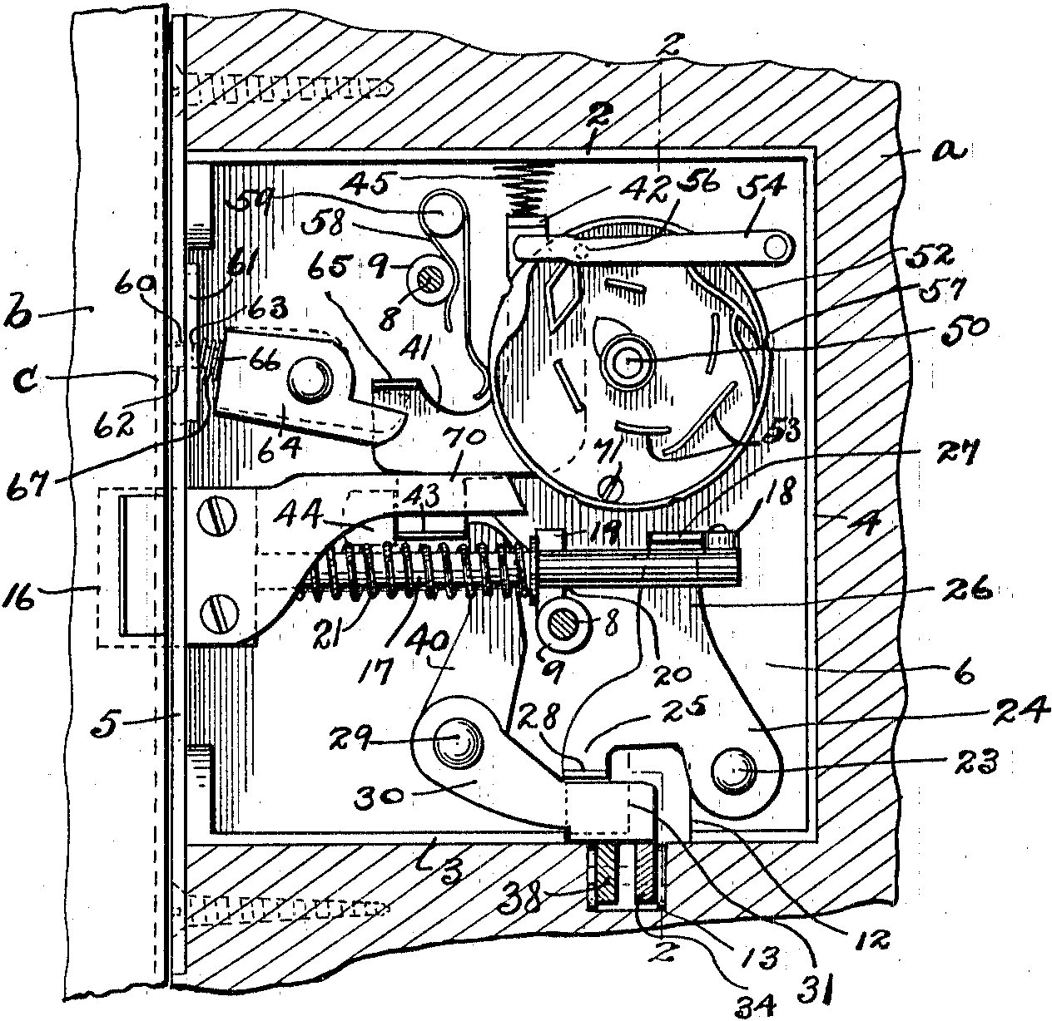
1,059,483 Combination Lock; 1/2/1912; 4/22/1913; James B. Miller, of Kent, Ohio, assignor to the J. B. Miller Keyless Lock Company, of Kent, Ohio, a corporation of Ohio.

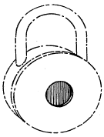
1929 -- Red Dot, i.e. the actual red dot, as well as the name “Red Dot” started being used on padlocks, per 1946 trademark 426,385 (the dot) and 424,030 (the name). Both applications are by the C. L. Gougler Keyless Lock Company, Lake Street, Kent, assigned to the C. L. Gougler Machine Company, Kent.

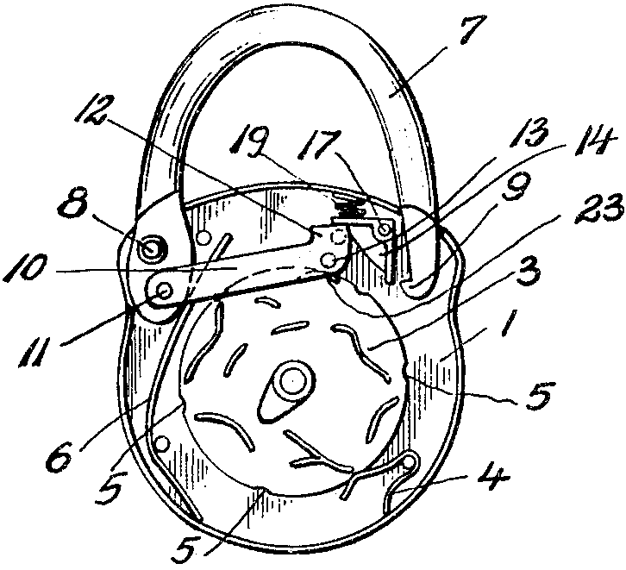
1,825,467 Keyless lock; 7/12/1929; 9/29/1931; Edward M. Miller, of Kent, Ohio, assignor to J. B. Miller Keyless Lock Company, of Kent, Ohio, a corporation. This is the first of two patent numbers commonly listed on padlocks.

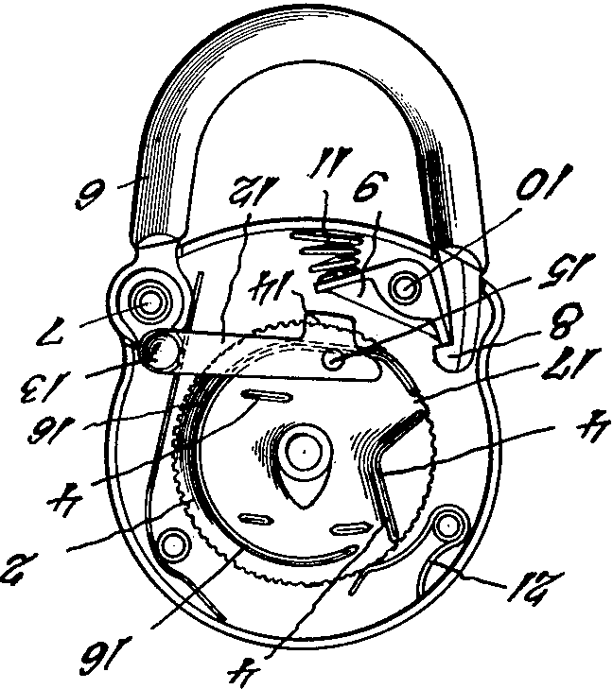
1,929,598 Keyless lock; 7/12/1931; 10/10/1933; Edward M. Miller, Kent, Ohio, assignor to The J. B. Miller Keyless Lock Co., Kent, Ohio, a corporation. I rotated the image so it can be compared with the previous one more easily. This is the second of two patent numbers commonly listed on padlocks.

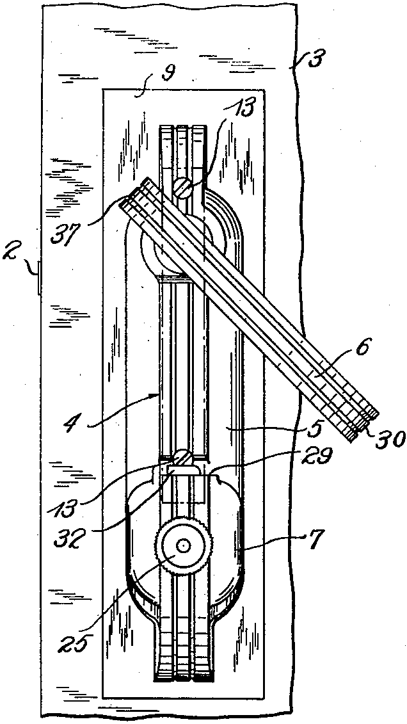
2,222,040 Lock; 1/12/1940; 11/19/1940; Edward M. Miller, Kent, Ohio, assignor to The J. B. Miller Keyless Lock Co., Kent, Ohio, a corporation.

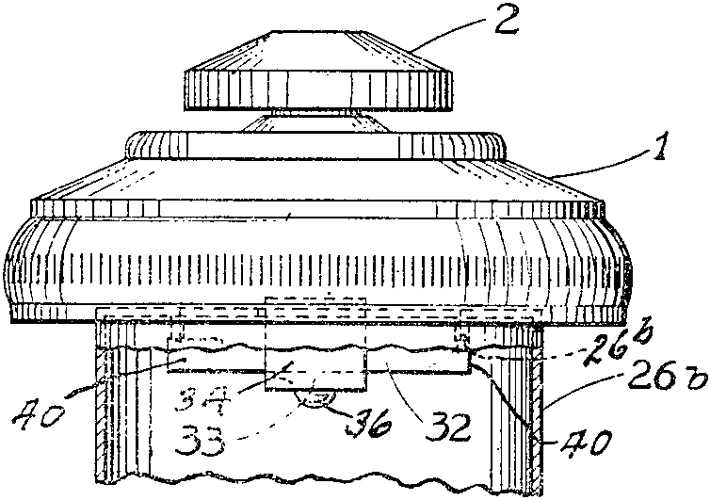
2,308,892 Filler pipe cap lock; 1/21/1941; 1/19/1943; Edward M. Miller, Kent, Ohio, assignor to The J. B. Miller Keyless Lock Co., Kent, Ohio, a corporation. This patent is referenced in 2,441,895.

2,348,064 Article Finishing Apparatus and Method; 4/8/1942; 5/2/1944; Charles W. Gebhardt, Kent, Ohio, assignor to The C. L. Gougler Machine Company, Kent, Ohio, a corporation of Ohio. It is not clear if this machine was used for production of locks and/or other articles.

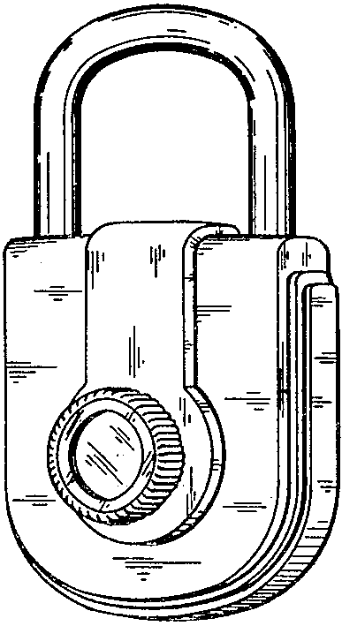
D144,682 Keyless Lock; 10/8/1945; 5/14/1946; E. F. Bouhall, assignor to The C. L. Gougler Keyless Lock Company, Kent, Ohio.

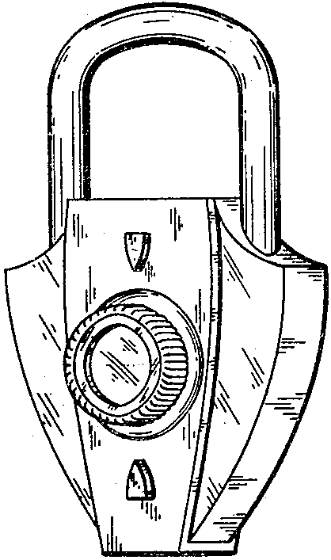
D144,683 Keyless Lock; 10/8/1945; 5/14/1946; E. F. Bouhall, assignor to The C. L. Gougler Keyless Lock Company, Kent, Ohio.

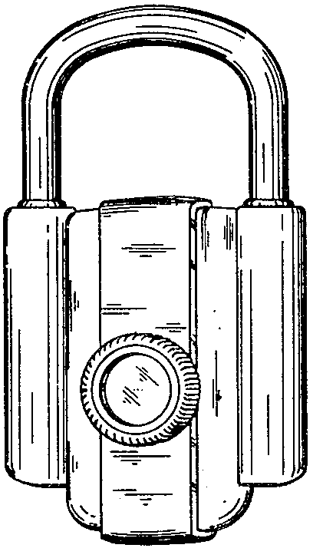
D144,684 Keyless Lock; 10/8/1945; 5/14/1946; E. F. Bouhall, assignor to The C. L. Gougler Keyless Lock Company, Kent, Ohio.

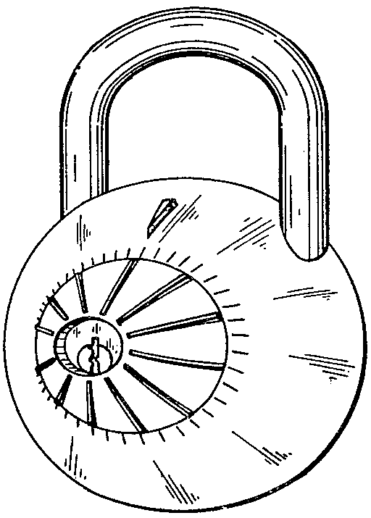
D144,685 Combination Keyless and Key Lock; 10/8/1945; 5/14/1946; E. F. Bouhall, assignor to The C. L. Gougler Keyless Lock Company, Kent, Ohio.

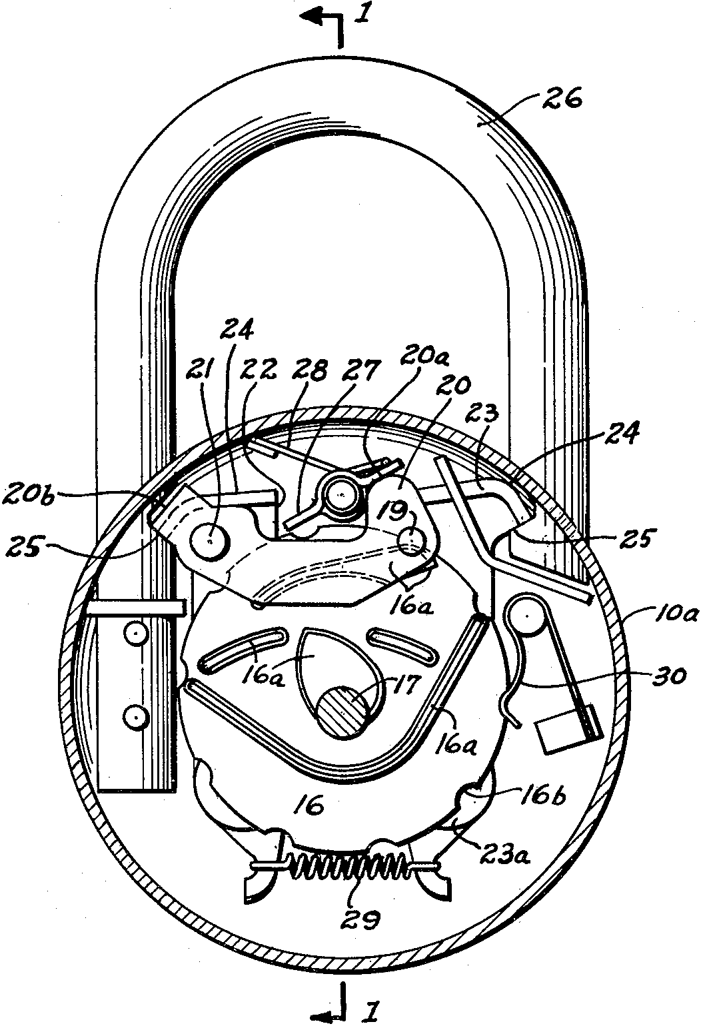
2,441,895 Stop ring for combination locks; 5/2/1946; 5/18/1948; Edward M. Miller, Kent, Ohio, assignor to The C. L. Gougler Machine Company, Kent, Ohio, a corporation of Ohio. This might have been used only in the model 200 round-faced lock. The few other-style locks whose inner workings have been exposed used a “hooked” cam surface to capture the stylus.

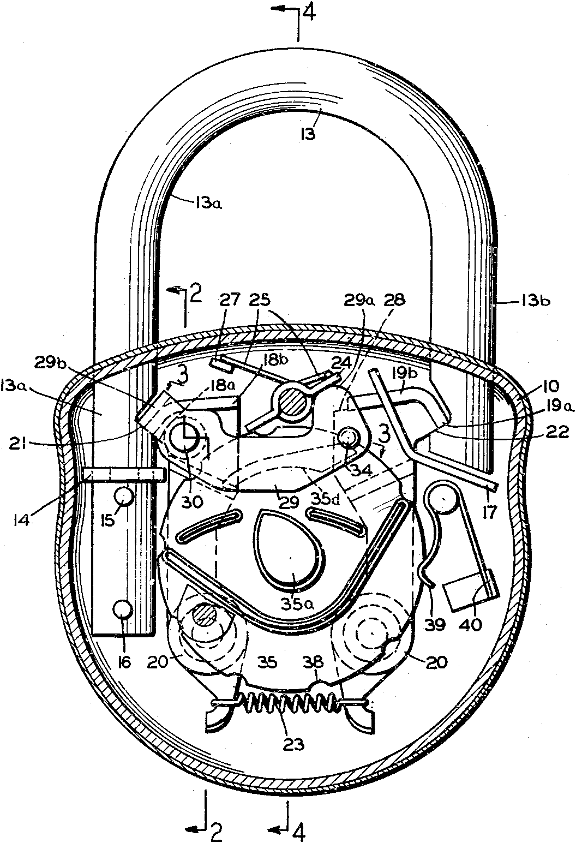
2,477,325 Padlock (pop-up shackle); 5/31/1946; 7/26/1949; Michael A. Yakubik, Hudson, Ohio, assignor to The C. L. Gougler Machine Company, Kent, Ohio, a corporation of Ohio. This patent is referenced in 2,441,895.

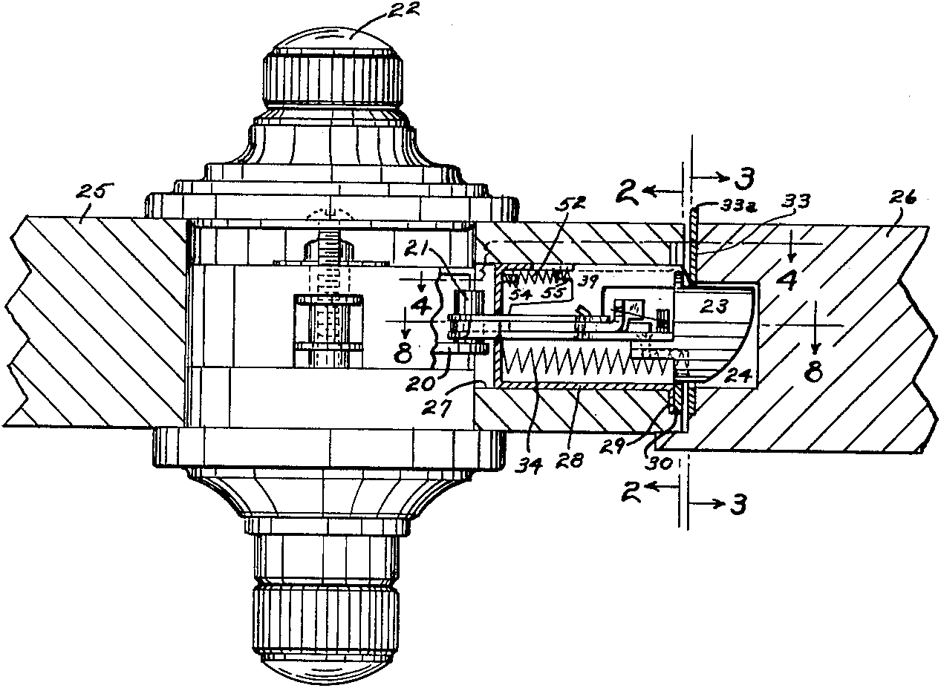
2,549,983 Deadlocking latch; 3/11/1948; 4/24/1951; Edward M. Miller, Kent, Ohio, assignor to The C. L. Gougler Machine Company, Kent, Ohio, a corporation of Ohio.

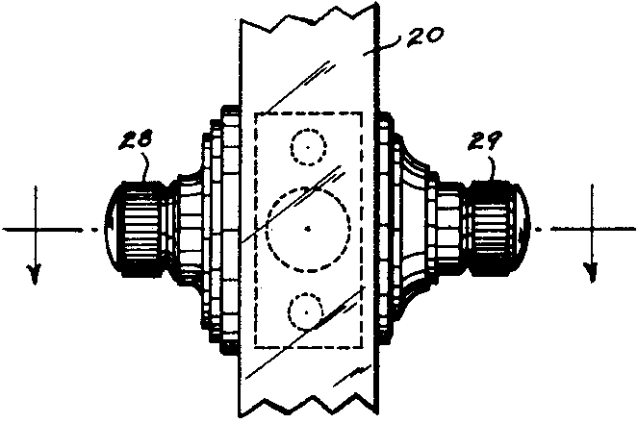
2,645,925 Combination controlled night latch; 3/11/1948; 7/21/1953; Edward M. Miller, Kent, Ohio, assignor to The C. L. Gougler Machine Company, Kent, Ohio, a corporation of Ohio.

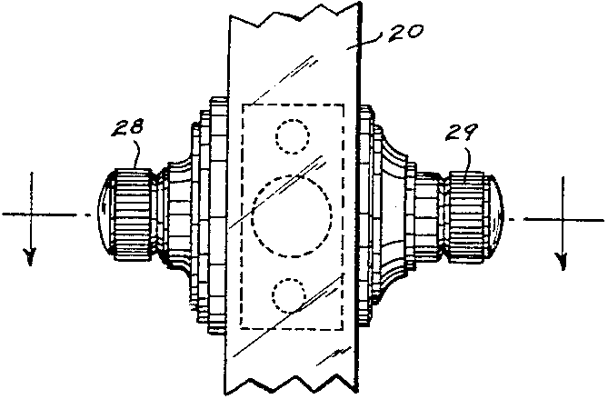
2,712,956 Door lock; 3/11/1948; 7/12/1955; Edward M. Miller, Kent, Ohio, assignor to The C. L. Gougler Machine Company, Kent, Ohio, a corporation of Ohio.

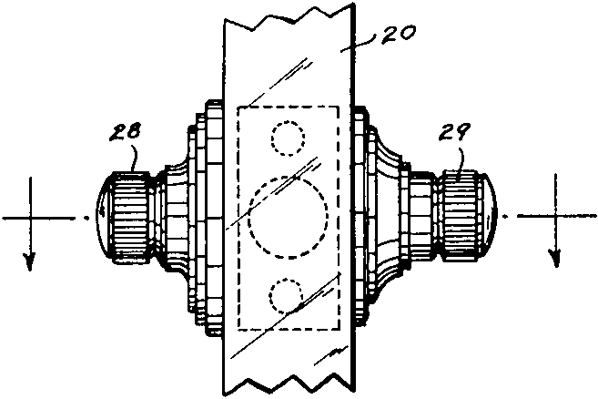
2,756,582 Lock housing; 3/11/1948; 7/31/1956; Edward M. Miller, Kent, Ohio, assignor to The C. L. Gougler Machine Company, Kent, Ohio, a corporation of Ohio.

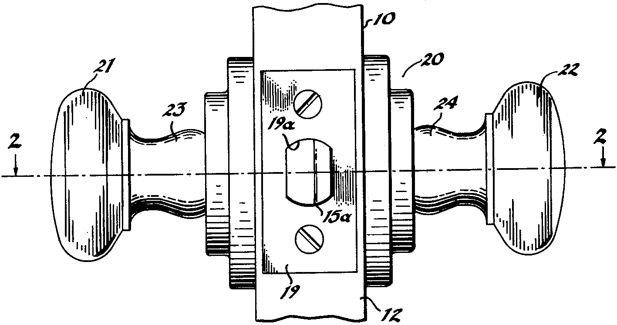
2,789,425 Knob actuated combination lock; 9/15/1953; 4/23/1957; Edward M. Miller, Kent, Ohio, assignor to The C. L. Gougler Machine Company, Kent, Ohio, a corporation of Ohio. This patent number is shown in a 1960s-era flier for the Type 83 shown elsewhere (from Gougler’s old web site).
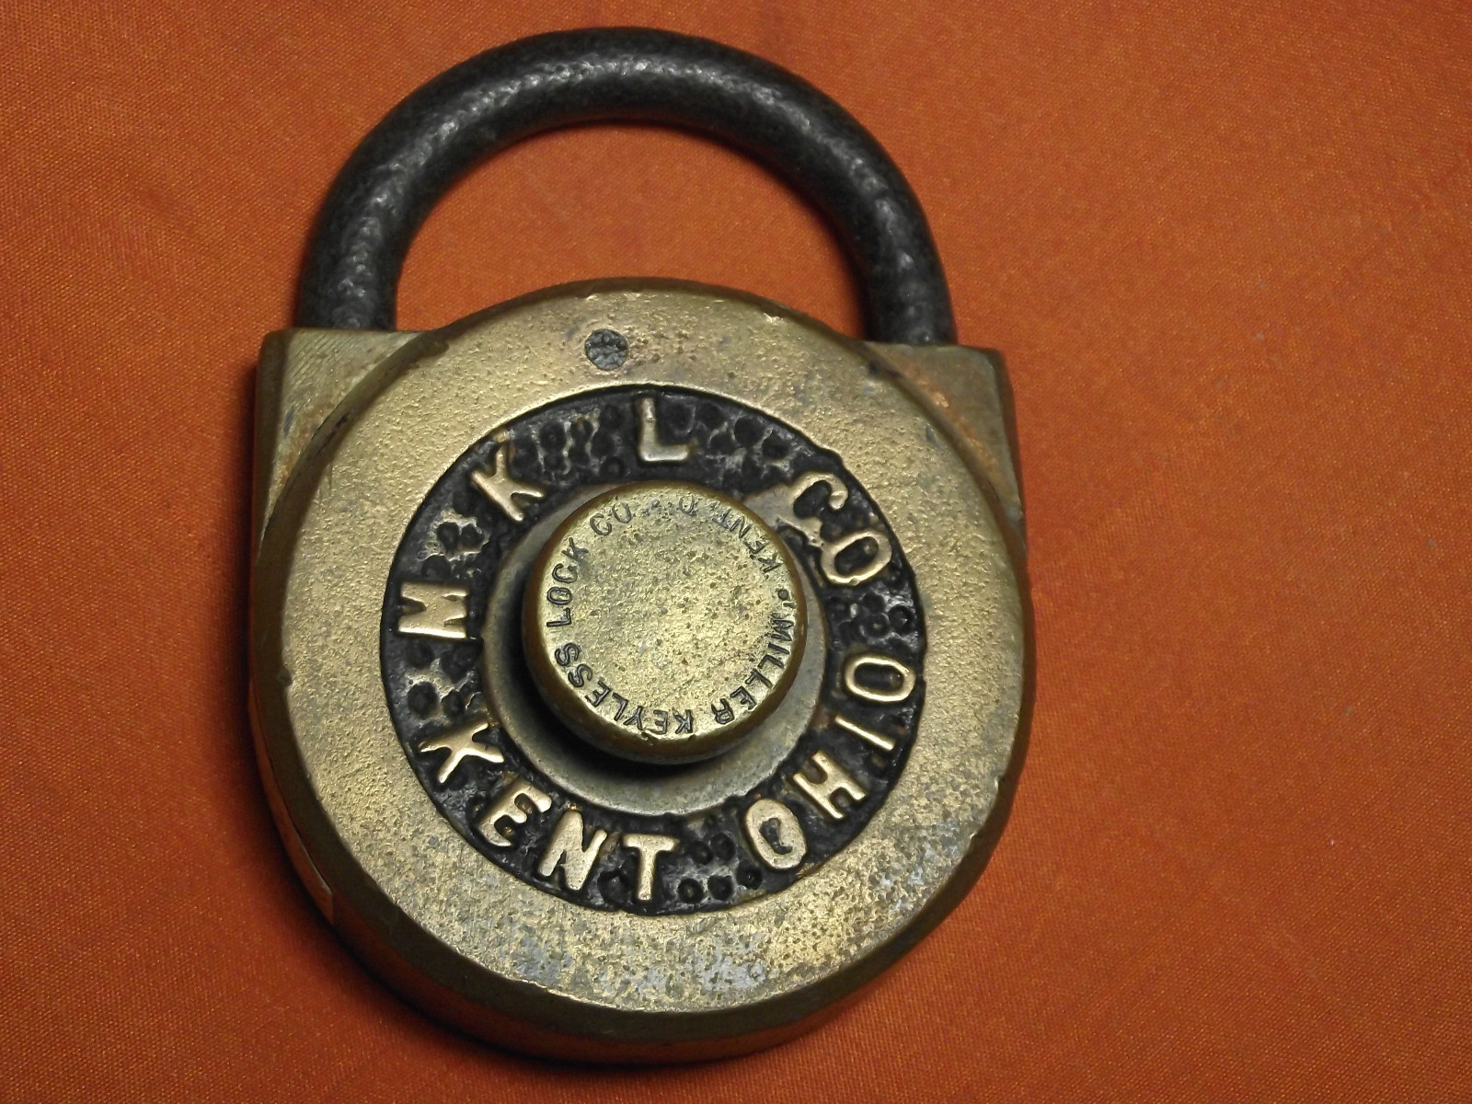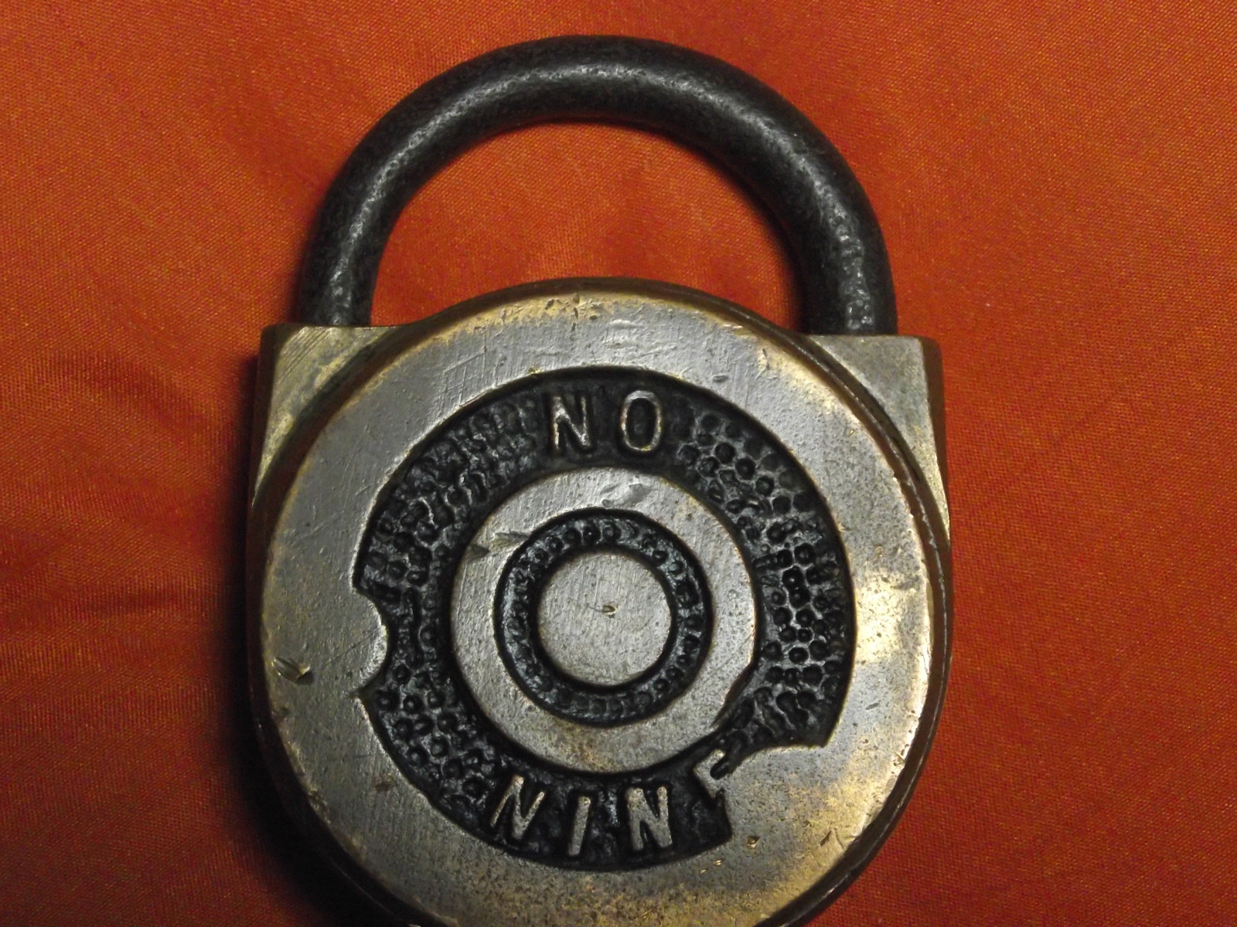

I don’t have this one.

This old number 9 is interesting because there is no patent date on the knob (see next lock) suggesting it predates the patent being granted, and it’s cast brass while the next lock looks much cheaper (but still the same style).

On antique-locks, user “Junker” figured out how to open the case. Simply put, take out the screw that hides under the shackle then twist the case back counterclockwise.
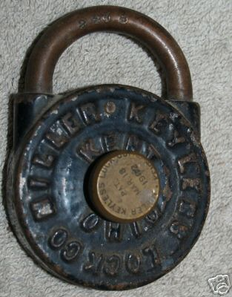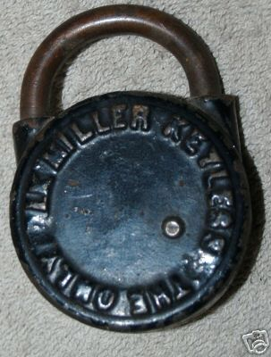

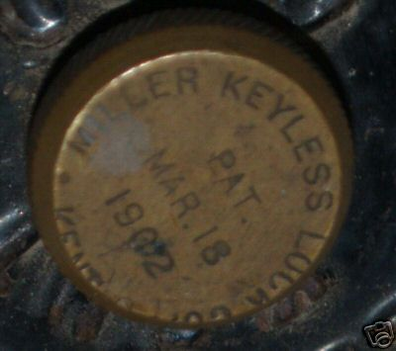

I don’t have this one.

The front says “Miller Keyless Lock Co--Kent Ohio” while the back says “The Only Lk Miller Keyless”. The dial shows a patent date of March 18, 1902. Although J.B. Miller does in fact have a patent with that date (695,472), it’s for an escutcheon plate. These pictures are from eBay auction 320240587333 4/22/08 which sold for $360.

This design looks like patent 863,868 (filed 12/7/1904, granted 8/20/1907) which is a click style lock.
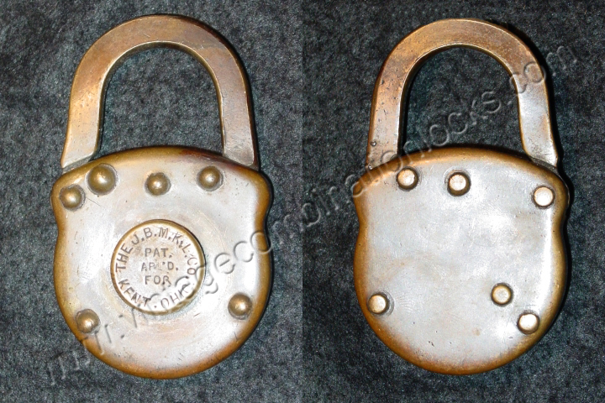

I don’t have this one. It looks like an early version of the Master Special, below. Note the rectangular cross-section of the brass shackle, and the brass case. The rivet pattern looks the same as the Master Special.
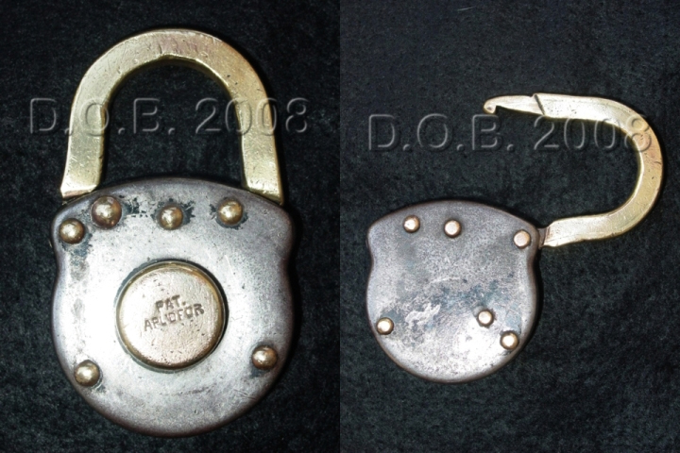

A cheaper/later version of the previous lock, here the case stamped steel rather than brass.
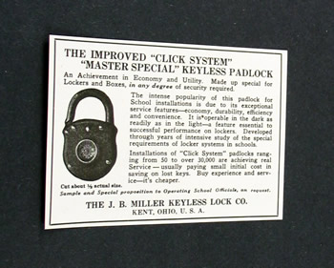

This ad (as seen on eBay) is claimed to be from 1929, and thus places this style lock as being from that general time. There is no mention of Red Dot in the ad. There is no mention of what makes the Master Special different than others.
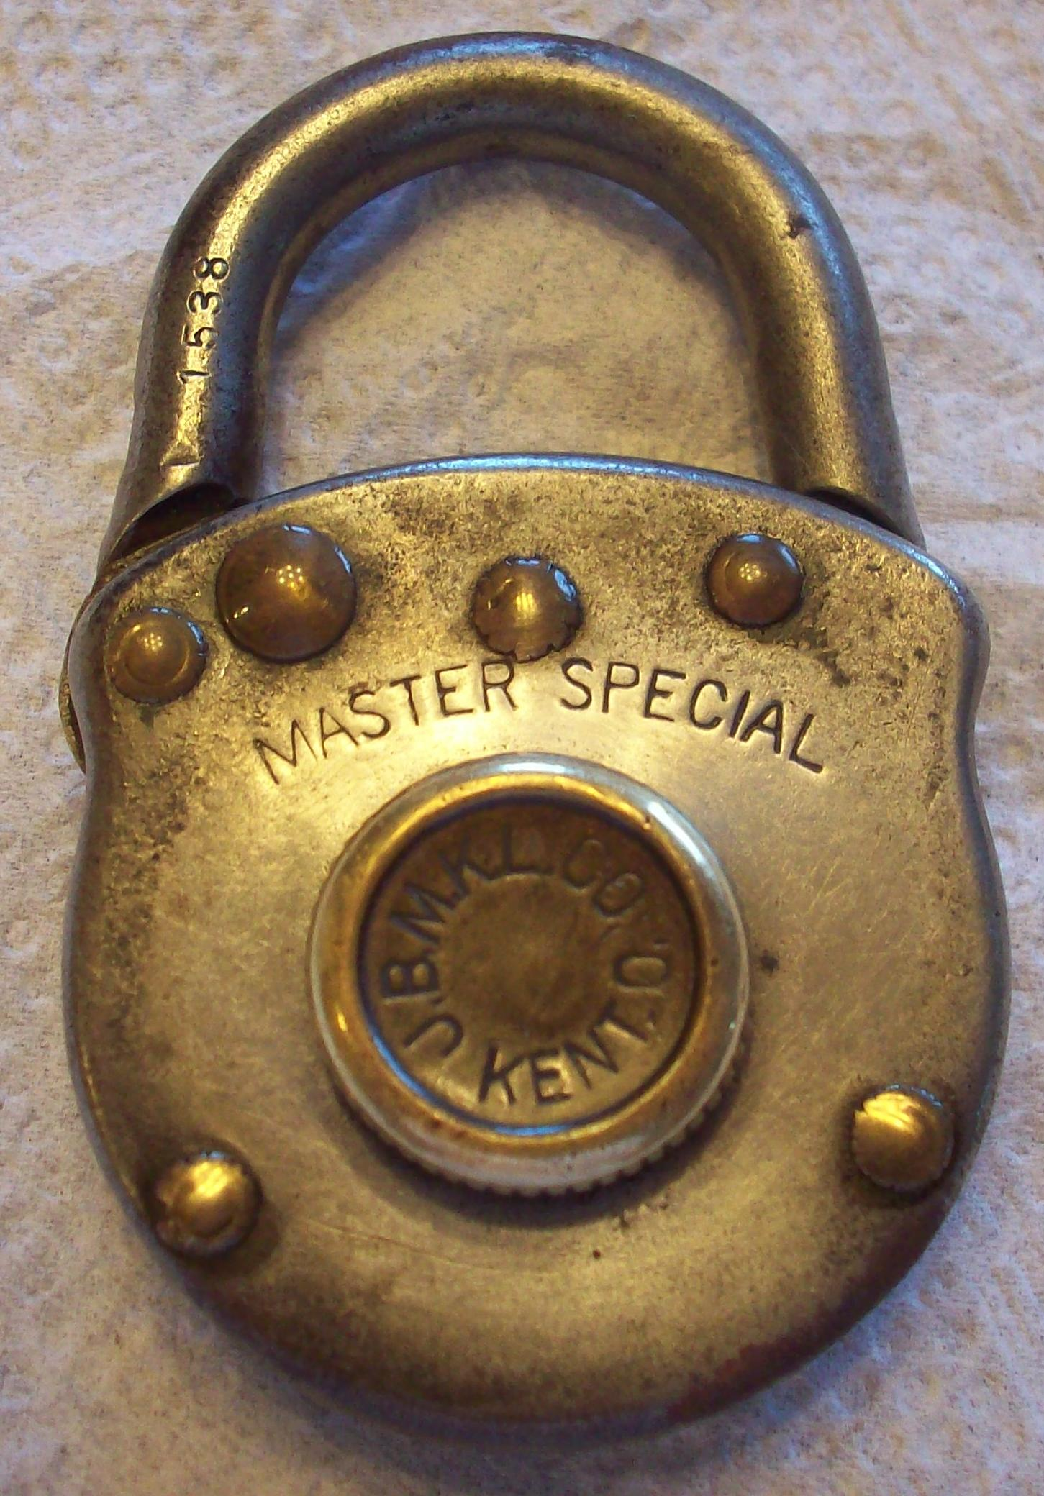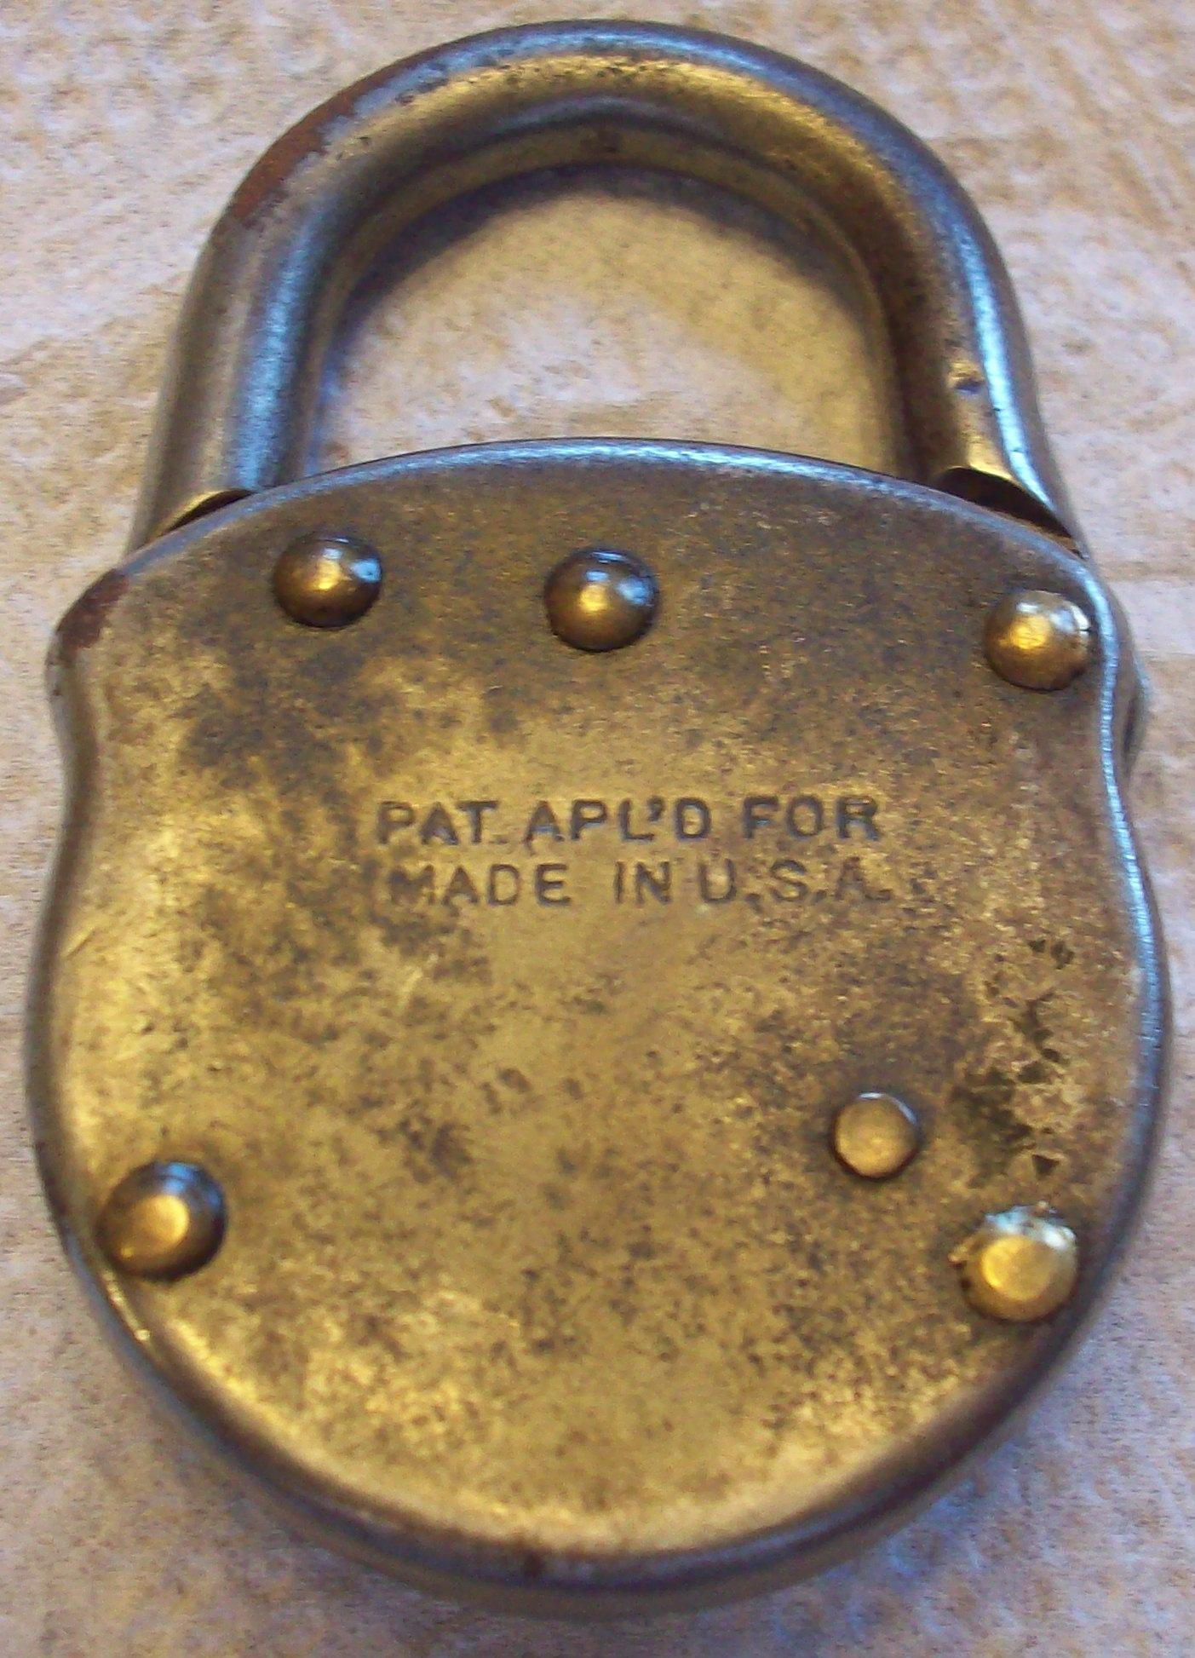

I don’t have this but it’s a nice image of the Master Special mentioned in the 1929 advertisement, above. There is no red dot, and no ring stamped into the front case. The combination is left to stop, then R5-7-5-3. The 1538 on the shackle is not the combination code, it is a serial number requested by the customer. I don’t see any combination in the code list that would match this.
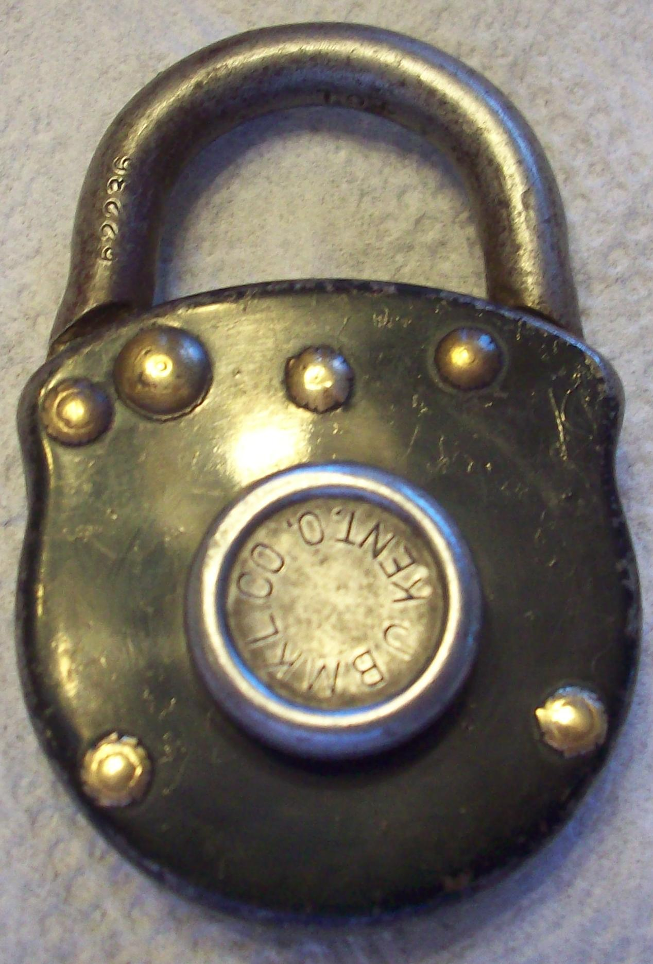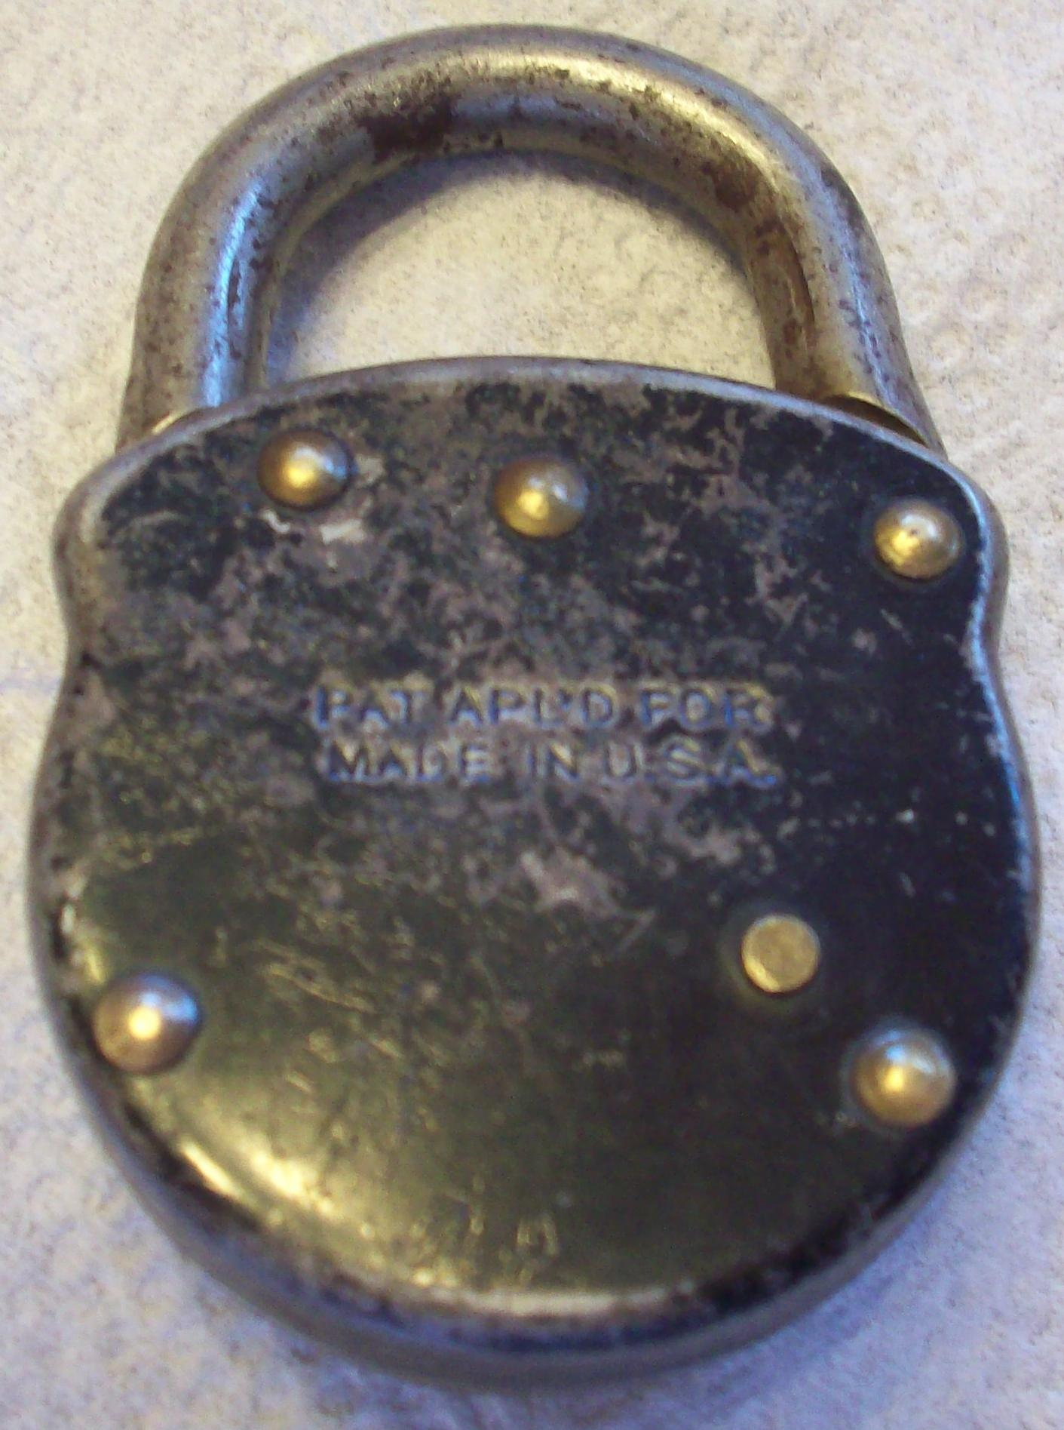

I don’t have this one but it’s a good example of the 1929-era lock just like the Master Special, earlier. No red dot, no stamped ring on the front case. The number on the left, 62236, is again a serial number. There was another number stamped on the underside of the shackle which is probably the combination code but it has become illegible from wear. The owner does not know the combination except that it probably begins with a “2” because that allows turning past what would otherwise be the stop in the opposite direction.
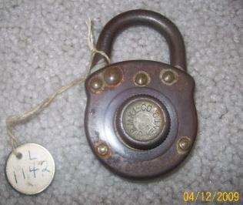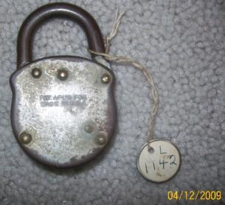

Lacks the red dot and the patent numbers. Probably predates the 1931 issue date of patent 1,825,487; but the patent was filed in 1929, so if the marking is truthful then it should date to between 1929 and 1931. The shackle is marked 77468, too long for a combination code, so it is likely a serial number requested by the customer. There may be faint traces of the code under the shackle but they are long gone. Another eBayer said this was their model #5 from the 1920s. Very stiff and nearly unworkable but it eventually did open: left to stop, R1-1-4-2. None of the known codes would yield this combination. The dial stops only when turned left. The combination is not cleared when the shackle is closed.

The dial appears to be stamped sheet metal with rolled knurls. Later ones are die cast (below, starting with the first red dot models). There is a ring around the dial stamped into the front cover, this might suggest that it post-dates other locks, above, which have a plain front. The shackle hinges on the left as viewed from the front. This will change later with the die-cast-case models.

The back is marked “Pat. Appl’d For” and “Made in U.S.A.”

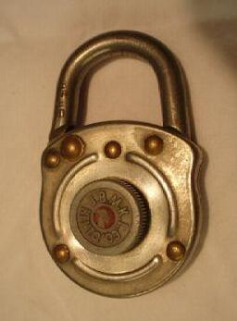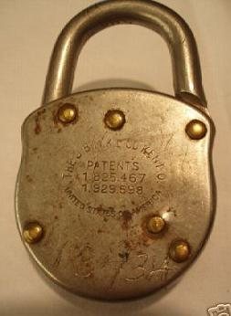

This is from 1933 or later, based on the second patent number, and probably no later than 1939 when the die cast models appeared. The back is now marked with the usual two patent numbers, and United States of America instead of Made in U.S.A.

The shackle is marked “-846” and “305” but it appears the code list does not apply to these older models. The 13434 scrawled on the back might be the combination but it does not work. The dial stops only when turned to the left.

Notice the interrupted ring stamped into the front case. The dial looks cast, in contrast to the earlier locks which seem to be made of sheet metal. Even if the red dot is worn off, there is an indentation which can help distinguish this style from the previous non-red-dot models.
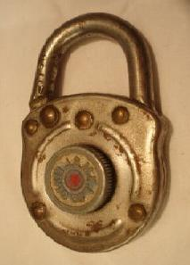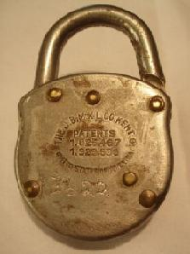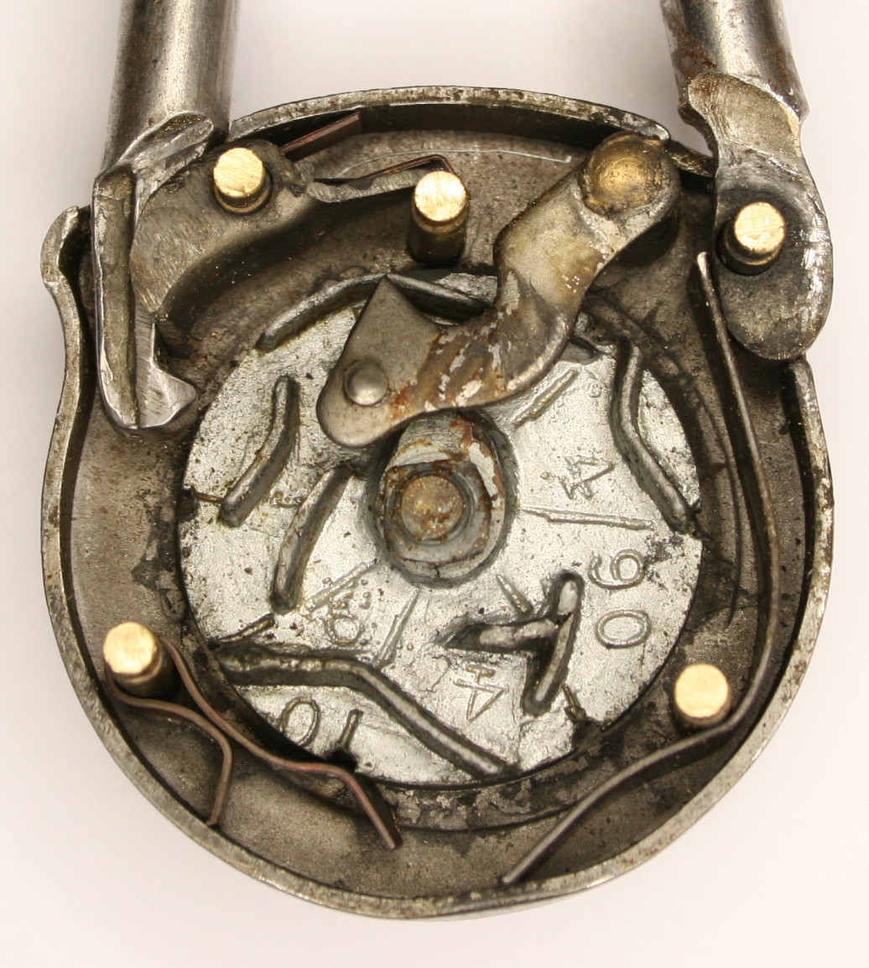

Essentially the same as the previous lock. The shackle is marked -1158, and 13622 is scrawled on the back. It also has “400” on the underside of the shackle which suggests a combination of L1-8-2-8 per the code list, which does not work.

There are traces of blue paint in the knob, in addition to the red dot. This might not be original (e.g. the owner might have painted his garage including the lock).

I opened this one up. The cam’s casting as well as overall workmanship is poor compared to later models. The dial stops in both directions which confounds attempts to determine the combination, as you don’t know which direction to start from.

The clicks are not evenly spaced.
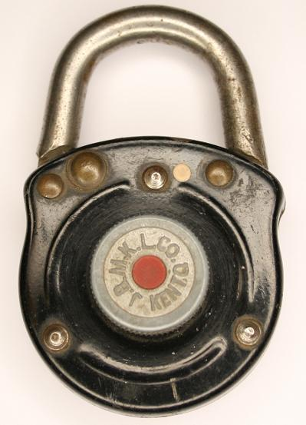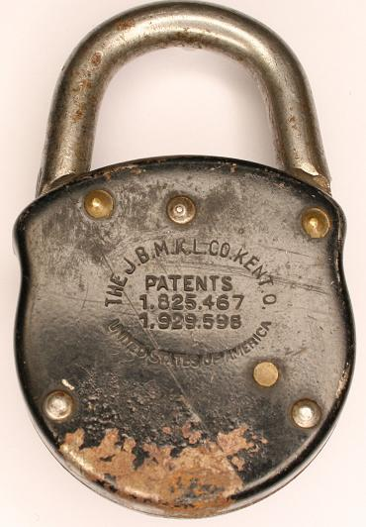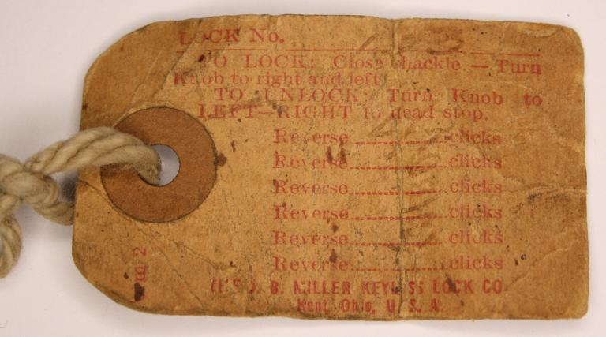

The shackle is marked “133” on the underside which matches the tag; the combination is “right to stop,” L4-6-3-3; this does not match the code list (L8-6-2-4) but there is a question mark on this entry. The dial stops only when turned right. At least this one works! Upon closing, the combination is not scrambled like the later locks; you need to spin the dial to actually lock it, which is in fact explained on the tag.
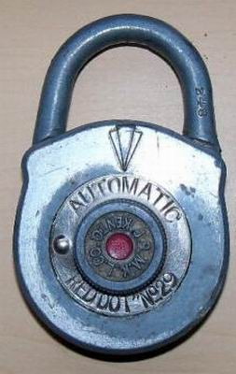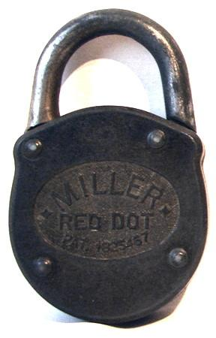

Number 29 “Automatic.” I don’t have this one; the image is from antique-locks where somebody was trying to determine the combination (248 stamped on the shackle). The second picture is of a different lock’s back; note the rivets and the single patent number which was granted in 1931.

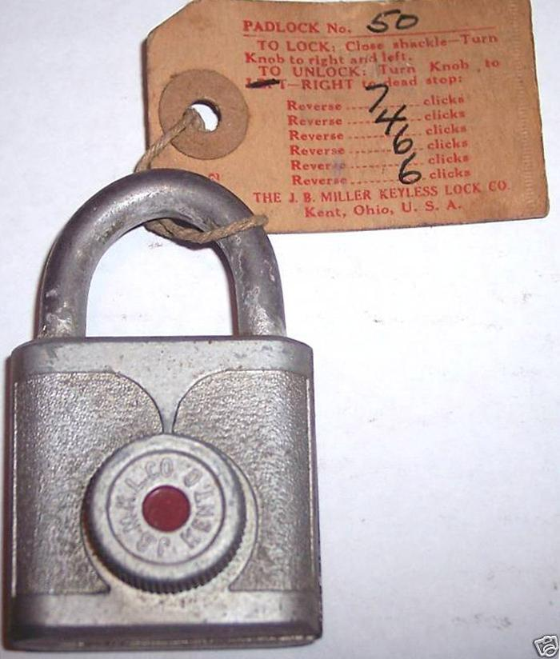

I don’t have this one.

I’m not sure if this belongs here in the sequence of things. It does say JBMKL which places it before 1944/1945 when Gougler took over. It strongly resembles design patents from 1945/1946 but the style is rare while the die-cast case, below, continued on into the 1970s if not the 1980s. So the presumption is that this case style did not work well and was dropped in favor of the later ones. Also note the two-digit code number as opposed to three- and four-digit codes later on. Presumably the shackle pops up instead of pivoting, there are two patents (above) that do this and those date from the second half of the 1940s. Best guess is late 1930s and/or 1940s.
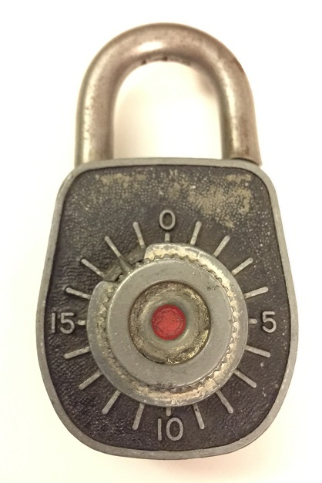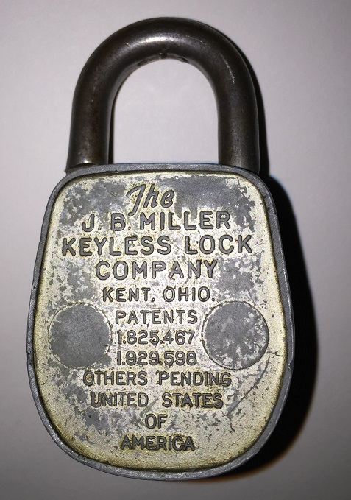

Possibly one of the first styles of die-case cases, this seems to use two flattened posts to hold the back cover on. Later ones seem to crimp the case over the back. Code 919 (?), this was seen on antique-locks. Compare with 155, next.

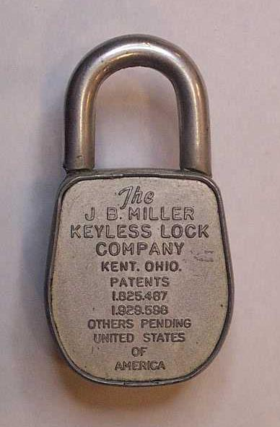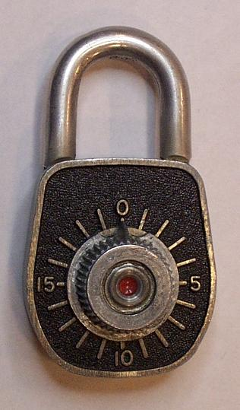

The back cover is roll-crimped on and the die-cast case is brush-finished. The patent list now includes “Others Pending.” The date is probably prior to 1944/1945 when Gougler took over, and after 1933 which is the second patent’s date. The earliest ad seen so far with this style (Red Dot No. 35) is October 1939.

There is no dial stop mechanism.

155 on the underside of the shackle suggests a combination of L1-2-8-7 per the code list, but that combination does not work. The combination is unknown or the lock is broken. “15” on the side of the case.

Reed Padlock Code Book volume 2 section M has codes for Miller/Gougler padlocks (West Coast Lock Collectors newsletter, January 1997, page 12, though they claimed section W). But ‘155’ is not on that list.

The shackle hinge is now on the right (as viewed from the front).

It is presumed that all of this style will clear the combination upon closing, a nice improvement. Except the very first few of these, I don’t have the combination. For all that I do, they behave this way.
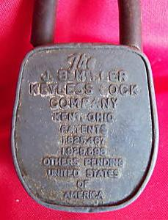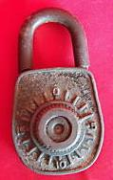

Similar to the previous lock, and now cut open.

Acquired on eBay 4/30/2009. T66 on case.

Something under the shackle but hard to read. Appears to be 562, implying L 7-3-7-5, which does not work (so far I’ve only worked out that the last number is “7”). The implication is that the stamped code is partly determined by the specific cam (which is stamped “62” and matches the last 2 digits of the code), and by the rotation of the cam on the shaft during assembly. There is no dial stop in either direction.
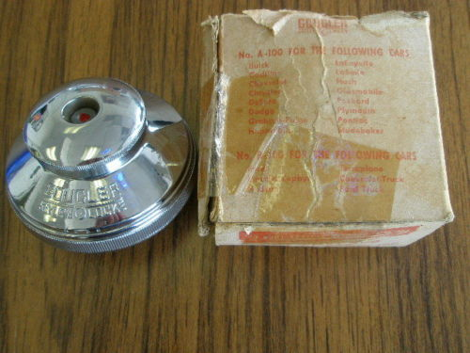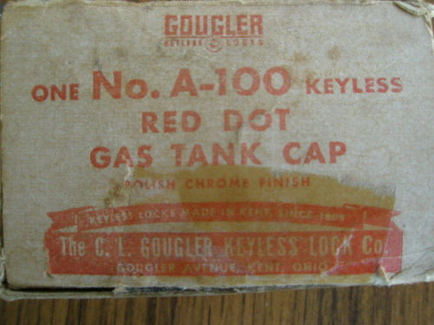

I don’t have this one. The eBay auction stated it was from the 1930s which is wrong. The patent is probably 2,308,892 which was filed in 1941. Because Gougler didn’t take over until 1945, this would have to be from perhaps 1945-1965 or so.
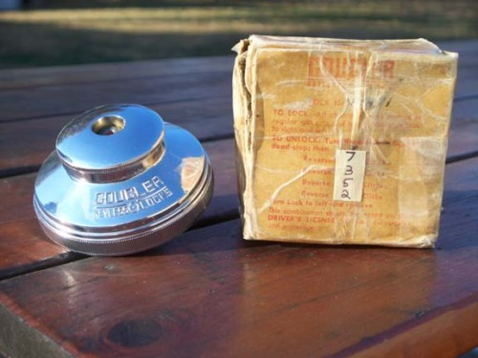

I do have this one, it is a Gougler B-100, with patent number 2,308,892 marked on the inside as well as on the ratty box; this was filed in 1941. Because Gougler didn’t take over until 1945, this would have to be from perhaps 1945-1965 or so. It is also marked 9089 (or 6806).
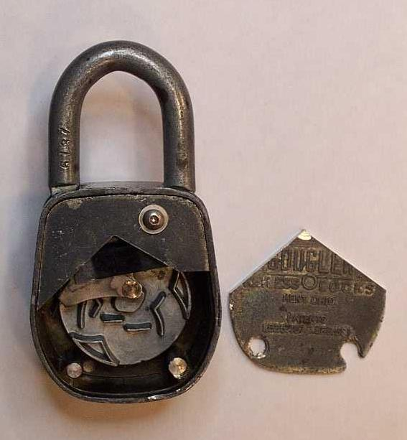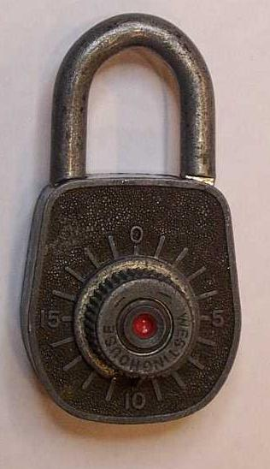

The knob says Westinghouse. Gougler added a circle between “Keyless” and “Locks” which may be a monochrome reference to the circular red dot trademark.

The 6137 on the back of the shackle suggests a combination of R0 then R1-3-5-2-4 per the code list, which does work. No dial stop in either direction.

A2575 on the side of the case. The patent numbers are now laid out horizontally.

These have the back held to the case via three peened-over pins, not by rolling the edge of the case. This must have been a production change Gougler made when they took over.

“United States of America” is gone, as is “Others Pending.”

This looks like a Gougler model 30-1.
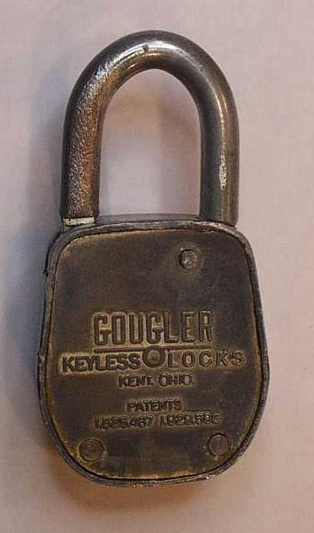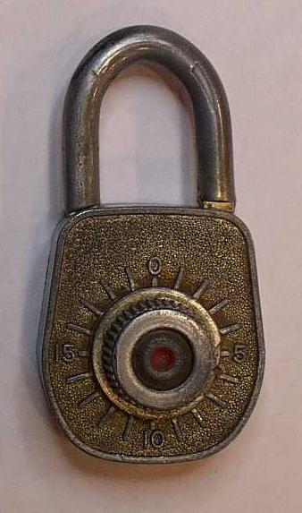

The dial stops in both directions.

If there was a number stamped on the shackle, it has been ground off.

The combination is R-to-stop, then L10-4-7-3 (a nice combo for a radio enthusiast, 10/4 and 73).

No markings on the case.

This looks like a Gougler model 30-S but it might be a 30-1.
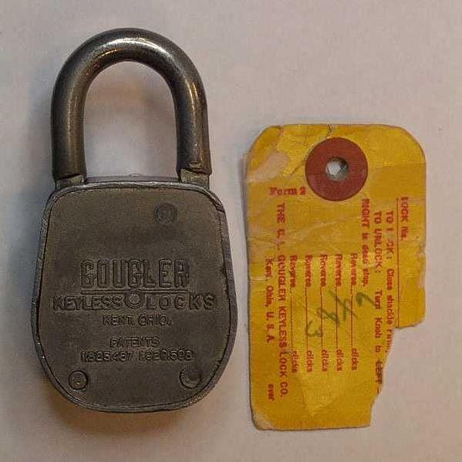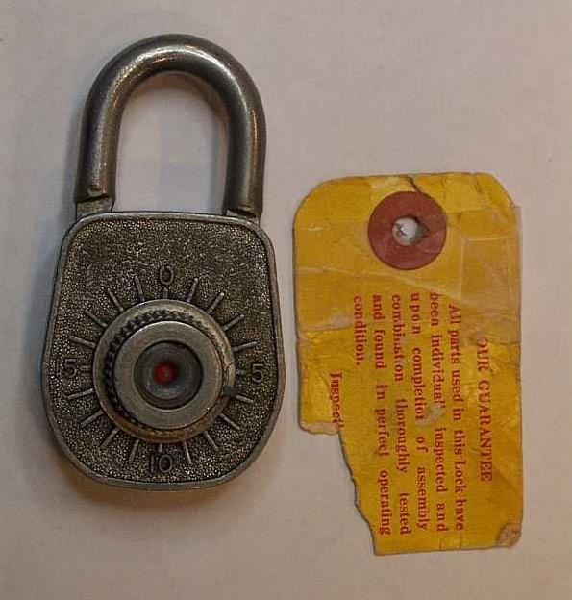

The dial stops in both directions.

7212 on the bottom of the case, which would imply R 1-8-3 from the code list, but the actual combination is right to stop, L 6-4-8-3. No markings on the case.

The tag is marked “The C.L. Gougler Keyless Lock Co., Kent, Ohio, U.S.A.” (no zip code).

Looks like a Gougler model 30-S but it might be the 30-1.
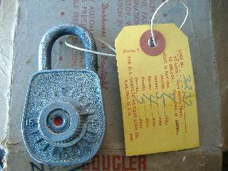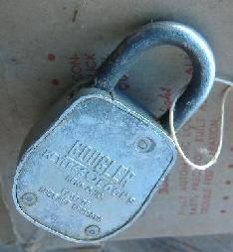

The dial stops in both directions.

3237 stamped lightly on the bottom of the case (not on the shackle; matches the tag) which the code list suggests is 9-4-7 but the actual combination is R stop, L9-5-4-7.

Gougler model 30-S.

The box that came with the lock is marked “The C. L. Gougler Keyless Lock Co.” and “Gougler Avenue, Kent, Ohio”. There is no zip code which implies a printing date prior to 1963/1964.

The tag is marked “The C.L. Gougler Keyless Lock Co., Kent, Ohio, U.S.A.” (no zip code).
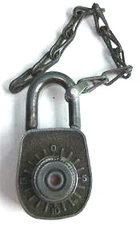
I have this one, it is an example from eBay of a Gougler lock with a chain. Code 443 on shackle should be L1-6-5-3 but that does not work.
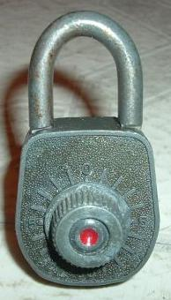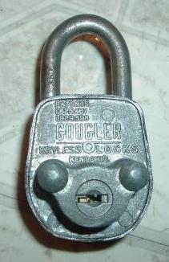

The 357 on the back of the shackle suggests a combination of L9-2-5-4 per the code list, which does work. The dial does not stop in either direction.

“A 265” appears on the side of the case.

Note the disc-tumbler bypass cylinder protruding from the back of the case, necessitating a different layout for the company name, patents, and so on. But the rivets are in the same location as non-bypass ones. It is assumed this predates the following models which use a flat key and a slot in the bottom of an expanded case. I believe the flat-key style is later because I’ve only seen Gouglers with disc tumblers, but the flat-key is seen in Gouglers and the later Millers.

The model number is unknown though one eBay auction claimed it’s Model 40 (also true for the other style, below). The same auction showed a tag labeled “The C. L. Gougler Keyless Lock Co, Kent, Ohio, U.S.A.” which suggests pre-1964 because there is no zip code.

There appear to be two potential key blanks. The first is the Ilco L1054B (also known as the EZ/Jet/Curtis IN8, and the Taylor L54B), though actual Curtis IN8 blanks appear to be a little short and “register” on a side groove rather than the bottom of the key; Curtis/EZ IN4 or Ilco 1054LB might be better, as far as length. The other is the Yale Y11 (also from Jet/Curtis/EZ; also known as the Taylor 7NX and Ilco O1122).
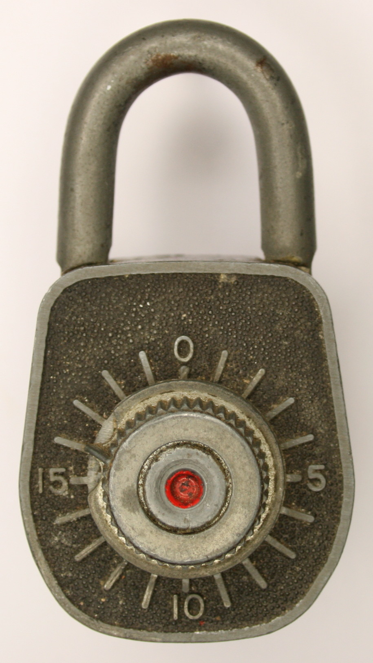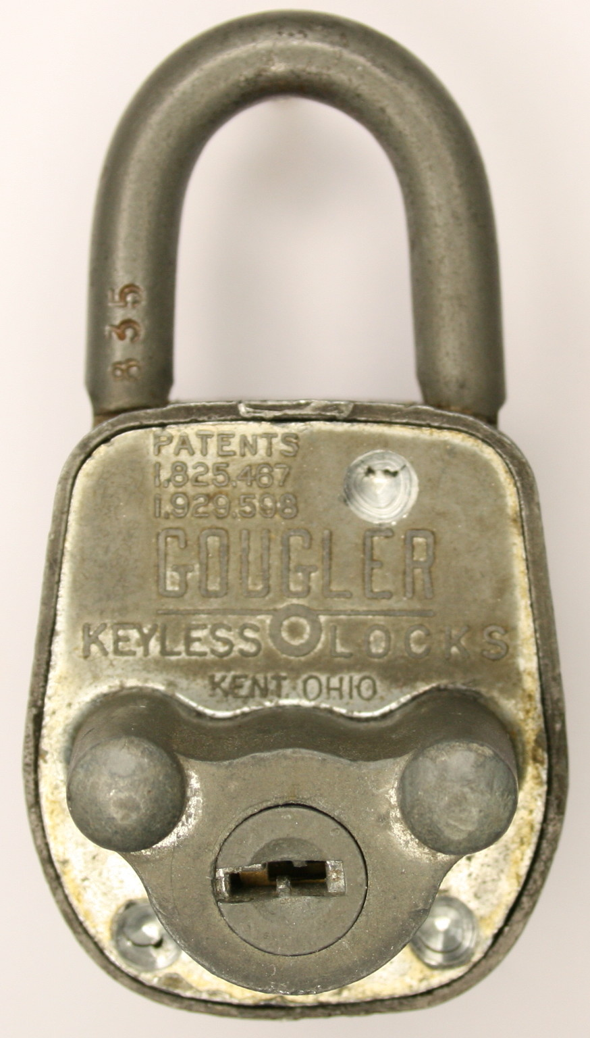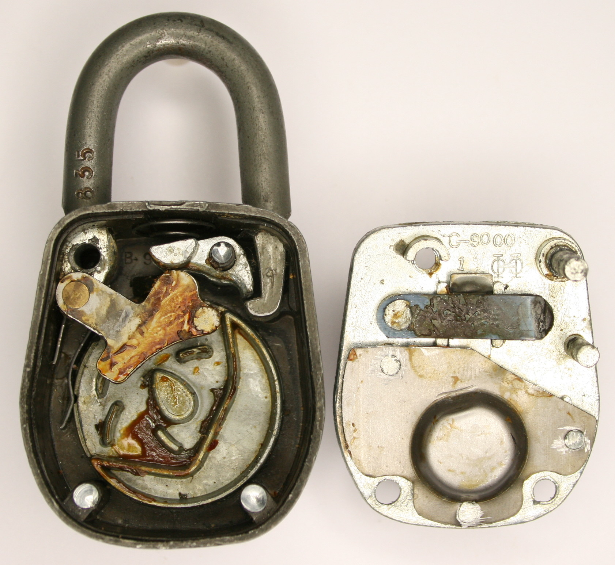

The 835 on the back of the shackle suggests a combination of L8-6-4-3 per the code list, which does work. The dial does not stop in either direction.

“767” on the bottom of the case.

This one has been opened up.

This one has 5 discs in the bypass cylinder, they probably all do.

The model number is unknown though one eBay auction claimed it’s Model 40 (also true for the other style, below). The same auction showed a tag labeled “The C. L. Gougler Keyless Lock Co, Kent, Ohio, U.S.A.” which suggests pre-1964 because there is no zip code.

There appear to be two potential key blanks. The first is the Ilco L1054B (also known as the EZ/Jet/Curtis IN8, and the Taylor L54B), though actual Curtis IN8 blanks appear to be a little short and “register” on a side groove rather than the bottom of the key; Curtis/EZ IN4 or Ilco 1054LB might be better, as far as length. The other is the Yale Y11 (also from Jet/Curtis/EZ; also known as the Taylor 7NX and Ilco O1122).
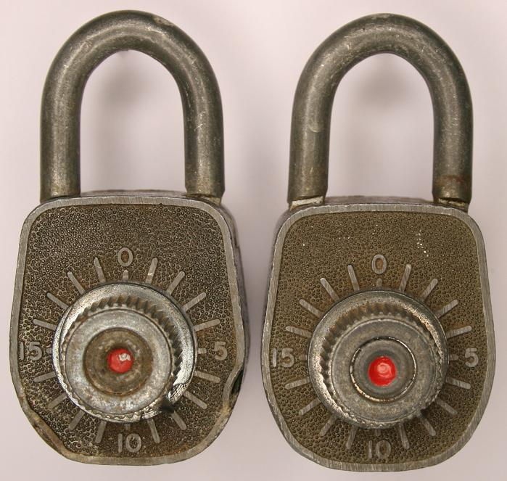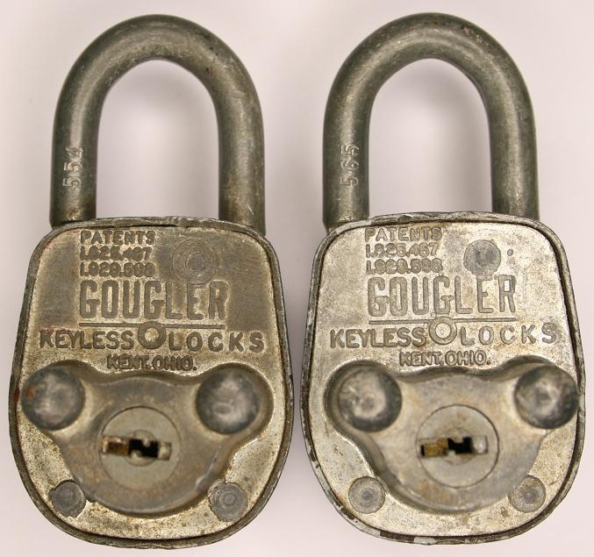

Two more, hoping to dismantle one for a key, and leave the other intact.

The 565 on the back of the shackle suggests a combination of L6-4-7-3 per the code list, which does work. On the other, 554 suggests L6-2-8-6 which works. There is no dial stop in either direction.

“2170” on the side of the case of the first. “2163” on the second, with “A” hand-scratched under it.

The model number is unknown though one eBay auction claimed it’s Model 40 (also true for the other style, below). The same auction showed a tag labeled “The C. L. Gougler Keyless Lock Co, Kent, Ohio, U.S.A.” which suggests pre-1964 because there is no zip code.

There appear to be two potential key blanks. The first is the Ilco L1054B (also known as the EZ/Jet/Curtis IN8, and the Taylor L54B), though actual Curtis IN8 blanks appear to be a little short and “register” on a side groove rather than the bottom of the key; Curtis/EZ IN4 or Ilco 1054LB might be better, as far as length. The other is the Yale Y11 (also from Jet/Curtis/EZ; also known as the Taylor 7NX and Ilco O1122).
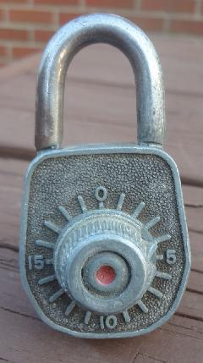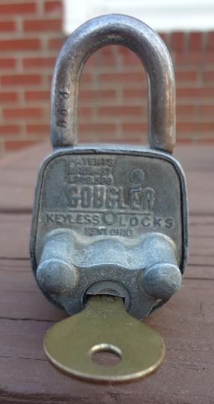

Another disc-tumbler version I bought from eBay (150817521142 5/23/2012) because it comes with what appears to be an original key.

Code number 553 on the shackle implies a combination of L4-2-8-4 which works but you have to rock the shackle back and forth; the mechanism might be damaged. The dial does not stop in either direction.

The key is stamped C242, while the case is stamped A304. I note that a CH751 key (common industrial key) fits well and could be adaptable, and/or the blank could be useful for Gougler locks.
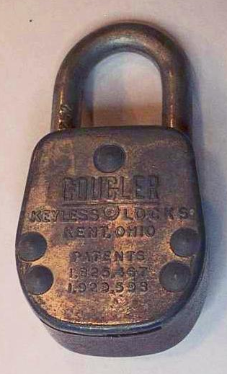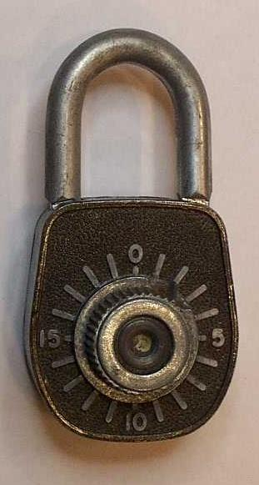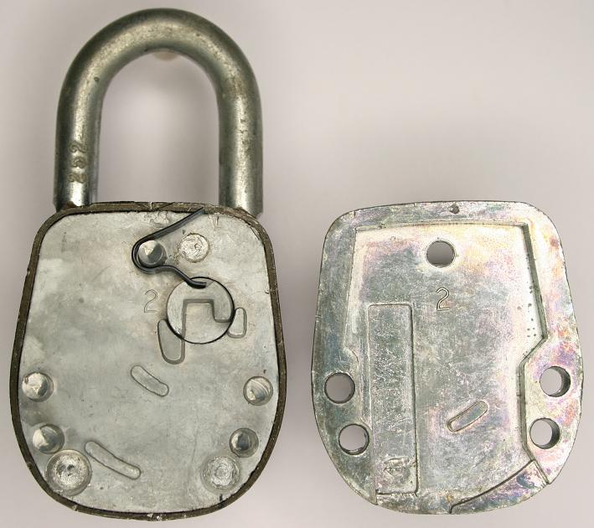

This one and the next 3 have a slot in the bottom for a master key, do not have a dial stop, and notice the patents are listed vertically instead of horizontally as on other Gougler flat-backed locks. The inside cover has “2” stamped on it, possibly designating the bypass key. These might have been introduced in 1957 based on articles in 1957 magazines describing a “master key [that] cannot be duplicated by any commercial key machine” and showing a flat key.

252 on the shackle; L0 then L9-4-8-4 per the code list, which works.

981 appears on the side of the case.

It has been suggested that the shackle number is a locker number so that a lost lock can be reunited with its proper locker, while the number on the case is a blind code that could be found in the school’s codebook. But this particular lock suggests the opposite is true and happens to have a code that matches the “public” codes.

Gougler model 40.
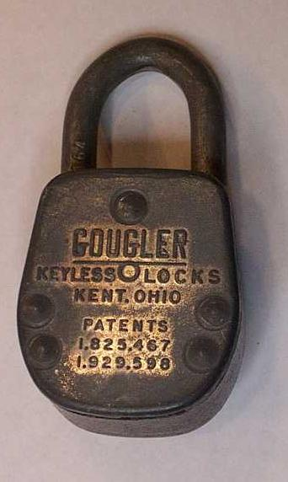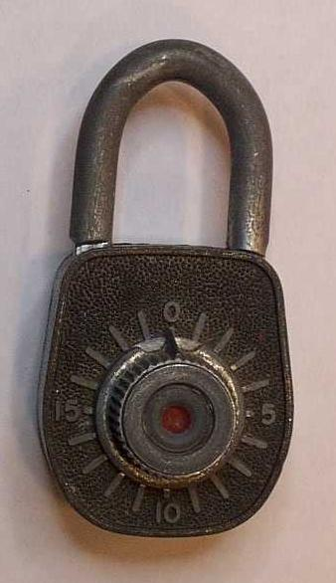

164 on the shackle, L0 then L8-4-2-6 per the code list, which works. No dial stop.

1257 on the side of the case.

Gougler model 40.
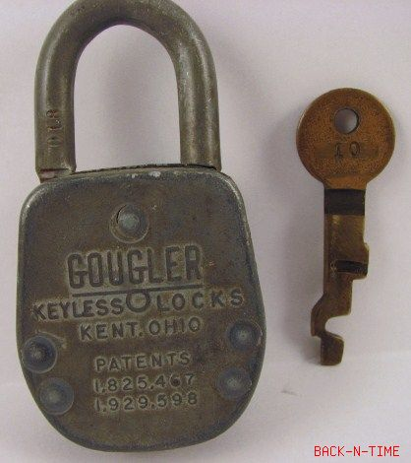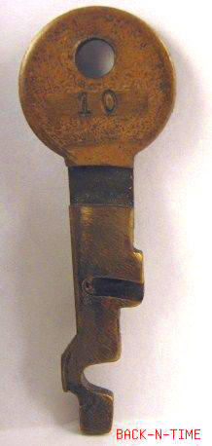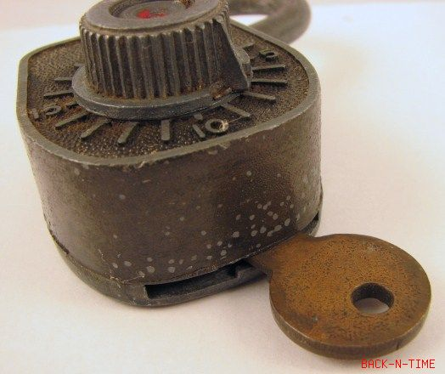

I don’t have this lock, it was for sale on eBay. It’s notable because it included a key. This key appears to be brass that was stamped then machined, compare to the next lock.
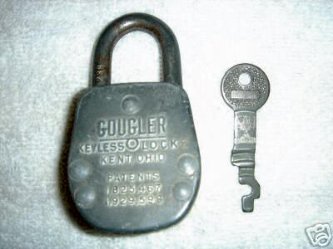

I don’t have this one, it was for sale on eBay and was notable because it included a key. This key looks like it is either steel or nickel-silver; it was marked “180”. Compare to the previous key which was brass, and stamped and machined.
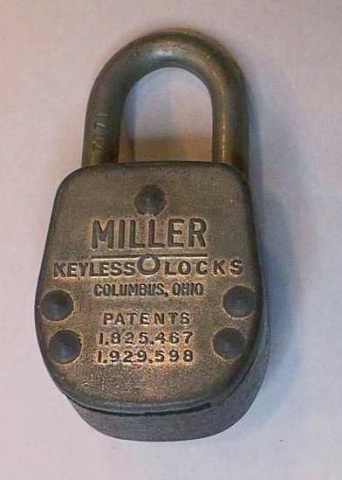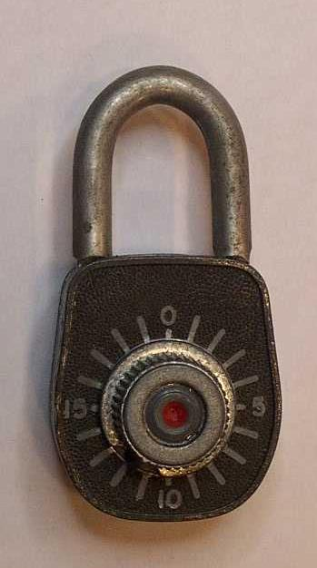

7071 on the shackle. If you drop the zero and call it 771, then the code list suggests L0 then L6-4-7-5 which works. No dial stop.

2031 on the side of the case.

Note it now says Columbus, not Kent, and Miller rather than Gougler.

Looks like the Gougler model 40; did Miller use the same model numbers?
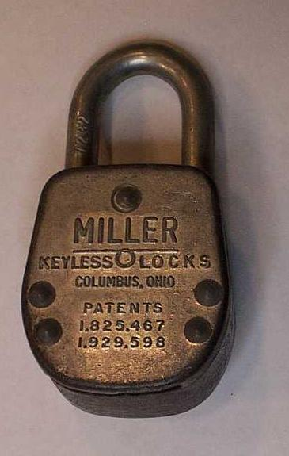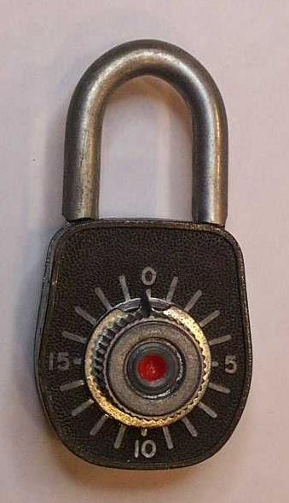

7232 on the shackle, suggesting R0 then R7-7-6 per the code list, which works. No dial stop.

1985 on the side of the case.

Looks like the Gougler model 40; did Miller use the same model numbers?
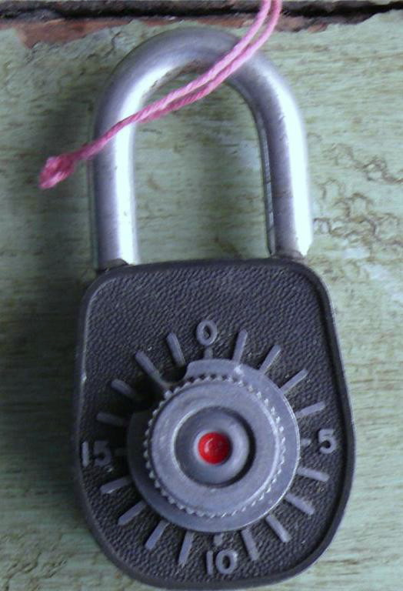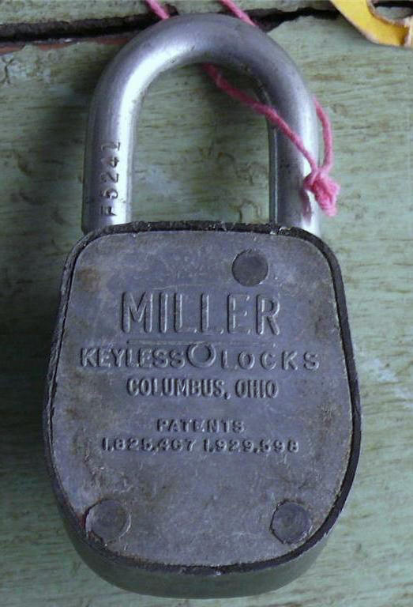

This looks like the non-key-bypass version of the ones above. The patents are laid out horizontally again. But, the tag says “The C. L. Gougler Keyless Lock Co.” of Kent. So, perhaps Miller acquired a stack of tags from Gougler and used them, instead of discarding them and printing their own right away? The code is F5241. The combination is L to stop; R11-9-7. The code list does not have “F” codes, but I do note that the bare code for 241 is R-1-9-7 which is strongly related.
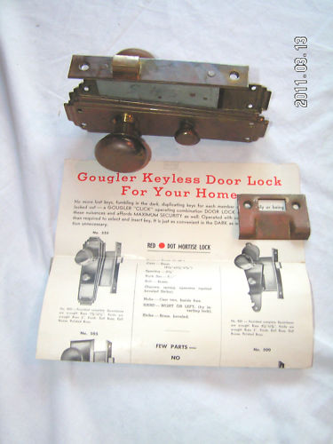
I don’t have this one. Seen on eBay, the seller wrote: You are bidding on a vintage C.L.GOUGLER KEYLESS DOOR LOCK for your home. Lock is brass with steel interior parts, is in good shape and is marked in pencil 545, but does look like the 525 model.
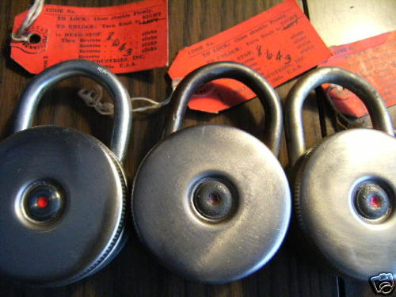

I don’t actually have any of these, but the back says “Miller Keyless Locks” and “Cols. Ohio” and “Pat Pend” which is interesting because all earlier padlocks listed two patent numbers; perhaps these are based on Yakubik’s 1949 patent and/or Miller’s 1948 patent, but these seem well after that. The tags and box say “Miller Industries, Inc” and “Columbus, Ohio”. The eBay auction (180217124950, Feb 2008) also includes a photo showing an unreadable address on the box, which appears to include a zip code suggesting a date after mid-1963. The tags also suggest these have the dial stop feature, which you’d need with no pointer or markings. These look like Gougler’s model RD200 Deluxe, but made by the later Miller company. Another point in time is a claim by eBay user “dtwiant” that in 1964 the daughter of the Gougler company owner was married, and guests were given commemorative locks; the same writer claims Gougler sold the lock division in 1986 to 5 stockholders, who sold it to the Miller company.

Others have been seen that read “Gougler Keyless Locks, Kent, Ohio, Pat. Pend.” which would predate these Millers.

Materials suggest model number 200 and RD200 (201 for the long-shackle model).
Bibliography:

Association Men was a magazine published by the YMCA and included ads placed by the JB Miller company.

Brimfield and Its People, Life in a Western Reserve Township 1816-1941 by Edgar L. McCormick. A hard to follow, rambling recollection. There were many Millers including James and Ned (and presumably Jamie), it’s unclear if they are all related. At least it establishes where they lived and who James’ wife was.

dtwiant is an eBay user who worked for Gougler in 1956 and sold some Gougler locks in 2006 and provided a history of the company, some of which I disagree with (for example that the new Miller company existed in 1986) or cannot yet be corroborated (Gougler sold the lock division to 5 stockholders, who later sold it to the new Miller company).

Gougler’s Web Site (which is gone, use https://web.archive.org/web/20110728102227/http://www.gougler.com/locks/locks.htm instead) includes pages about their old lock division and some advertising materials from, I’m guessing, the 1960s. The last name of the company was Gougler Industries, Inc. though the web site included an image from a building that said “The C. L. Gougler Machine Co.” The name of the lock division was “The C. L. Gougler Keyless Lock Company” on some of the advertising materials and elsewhere. The address was 705 Lake Street, and on the advertisements 705-769 Lake Street (Kent, Ohio).

Portage Pathways by Loris C. Troyer, 1998. Loris wrote a frequent column called Portage Pathways for a newspaper called the Record-Courier. The book is a collection of those articles, which includes one entitled “History Locked Up in Versatile Kent Product” which is about the Miller/Gougler/Miller companies, originally published February 5, 1983, and reproduced on pages 284-286 of the book.

https://web.archive.org/web/20170913042232/http://www.vintagecombinationlocks.com had images and combinations of several Miller/Gougler/Miller padlocks including models not represented herein.

